ASSIGNMENT COVER SHEET

Student’s name | Hirushan | Thavaseelan
Module name | Software Engineering & Agile
Title of assignment | Webapp Project
Complete Word Count in my assignment

Date submitted

All work must be submitted by the due date. If an extension of time to submit work is required, a Mitigating Circumstances Extension Form must be submitted.
https://canvas.qa.com/courses/1041

Has an extension been approved? Yes No If yes, please give the new submission date ….…/..…./…….

IMPORTANT: THIS STATEMENT MUST BE READ & SIGNED

Academic Integrity Statement

Academic integrity and honesty are fundamental to the academic work you produce at the University of Roehampton. You are expected to complete coursework that is your own and which is referenced appropriately. The university has in place measures to detect academic dishonesty in all its forms. If you are found to be cheating or attempting to gain an unfair advantage over other students in any way, this is considered academic misconduct and you will be penalised accordingly.
​
I declare that the work I am submitting is my work, is properly referenced and has not been submitted elsewhere.

Student Signature (Full Name):

Date:

Table of Contents
Task 1 4
Summary of the Application and Dependencies 4
Problem Statement: 4
Scope of the Application: 4
Core Features: 4
Application Dependencies: 5
Design Documents: 5
High-Level Architecture Flowchart 6
Detailed Backend Flowchart 7
Entity Relationship Diagram 8
Instruction on running the application 9
Annotated Screenshots of the running application 10
Main page 10
Login page 12
Register page 13
Admin all tickets page 14
Admin all tickets page dark mode 14
Admin all tickets page on mobile 15
Admin all tickets page on mobile dark mode 16
Support assigned tickets page 17
Support assigned tickets page night mode 17
Support all tickets page on mobile 18
Support all tickets page on mobile dark mode 19
Regular user active tickets page 20
Regular user active tickets page night mode 20
Regular active tickets page on mobile 21
Regular active tickets page on mobile dark mod 22
Admin user unassigned tickets page 23
Admin user assigning ticket on unassigned tickets page flash message 23
Admin unassigned tickets page on mobile 24
Regular active tickets page on mobile dark mode 25
Admin user assigned ticket page 26
Admin user assigned ticket page 26
Admin user closed ticket page 27
Admin user closed ticket page 27
Support user unassigned ticket page 28
Support user closed ticket page 28
Support unassigned tickets page on mobile 29
Support unassigned tickets page on mobile dark mode 30
Regular user active ticket page 31
Regular user closed ticket page 31
Admin user create ticket page 32
Support user create ticket page 32
Regular user create ticket page 33
Any user create ticket duplicate ticket 33
Create ticket page on mobile 34
Admin user ticket detail page 35
Admin user ticket detail page 35
Support user ticket detail page 36
Support user ticket detail page 36
Regular user ticket detail page 37
Regular user ticket detail page 37
Profile update page 38
Update profile page mobile view 39
User manual on key features 40
Task 2 45
Web Application Development Using Agile Methodology 45
Introduction 45
Agile Development Practices Used 45
Task 3 47
Report II: Agile Overview 47
Introduction 47
Scrum Framework Overview 47
Comparison with Kanban 47
Comparison with Lean 48
Critical Evaluation of Scrum 48
Proposed Improvement: Hybrid Scrum-Kanban (Scrumban) 48
Conclusion 49
Bibliography 50

Task 1

Website address: http://13.43.60.97:5000/index

GitHub address: https://github.com/Hiru5han/QA-project-weabapp

Summary of the Application and Dependencies

Problem Statement:
This Help desk ticketing system aims to streamline the process to managing IT support requests at AWS. Quite often, support staff are overwhelmed by disorganised requests, leading to delays and unresolved issues. This system ensures that all requests are tracked, assigned, and resolved efficiently by enabling regular users to submit support tickets, which are then managed by support staff and the administrator.

Scope of the Application:
The Help Desk Ticketing System serves three types of users:
- Admins: Have full control over the system, including managing tickets, assigning and reassigning tickets to support staff, and deleting tickets.
- Support Staff: Manage tickets assigned to them, can assign tickets to themselves, update the status and priority of tickets, and comment on tickets to provide updates or request more information.
- Regular Users: Can create and view the status of their own tickets. They can also add comments to any ticket, allowing for communication with the support staff.

Core Features:
- Role-Based Access Control (RBAC): The system implements role-based permissions, ensuring users only have access to features relevant to their roles.
  - Admins can create tickets and view and manage all tickets, assign tickets, and delete them.
  - Support Staff can create tickets and manage assigned tickets and provide updates.
  - Regular Users can create tickets and view their ticket status.
- Ticket Creation and Management:
  - Users can submit tickets with a description of the issue, priority level (low, medium, high), and assign it to a support user (admin feature).
  - Admins and support staff can update ticket status and assign the ticket to a team member.
  - Tickets can be marked as “Open,” “In-Progress,” or “Closed.”
- Comments and Activity Logs: Users can comment on tickets to provide updates or ask for additional information. A complete log of ticket activity is maintained for future reference.
- Responsive UI: The user interface is built using Bootstrap to ensure the system works on desktops, tablets, and mobile devices.

Application Dependencies:
- Flask: Flask is used as the primary web framework to manage routing, session handling, and template rendering.
- Flask-Login: This library is used to manage user authentication, ensuring that users must log in to access their role-specific views.
- Flask-Moment: Used for rendering timestamps in a user-friendly format in the frontend.
- SQLite: By default, the application uses SQLite as the database for storing users, tickets, and comments.
- Werkzeug: Provides secure password hashing to protect user credentials.
- Jinja2: Templating engine used to dynamically render HTML pages with data.
- Bootstrap 4: A front-end framework for creating a responsive and mobile-first design.
- DataTables: A jQuery plugin used for enhancing HTML tables with pagination, sorting, and search features.

Design Documents:
- Database Design:
The application consists of three main entities:
  - User: Represents all users in the system (Admins, Support, and Regular Users). Each user has a unique ID, name, email, password, and role.
  - Ticket: Represents a support request. It has attributes like title, description, status, priority, and an associated user who created the ticket. Tickets may be assigned to support staff.
  - Comment: Stores user comments on tickets, providing a log of ticket activity. Each comment is linked to a ticket and a user.
- High-Level Architecture:
The application is designed following the MVC (Model-View-Controller) pattern:
  - Model (Data Layer): Contains models for Users, Tickets, and Comments, which map to database tables.
  - View (Presentation Layer): Uses HTML templates that are rendered by Flask, with dynamic data insertion using Jinja2.
  - Controller (Logic Layer): Flask handles routing and logic, controlling what data is passed to views and managing user sessions.
- Security Considerations:
- Authentication: Flask-Login is used to handle user authentication, ensuring only logged-in users can access restricted pages.
- Authorisation: Role-based access control ensures that different user types (Admin, Support, Regular User) have different permissions.
- Password Security: Passwords are hashed using Werkzeug before being stored in the database.
High-Level Architecture Flowchart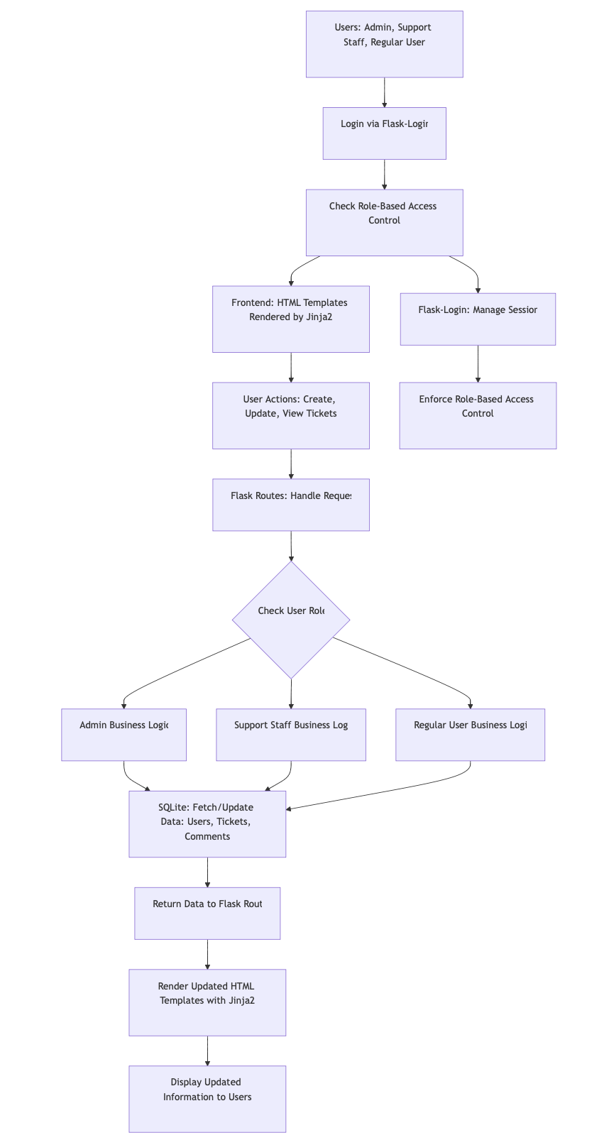
Figure 1 - High-Level Architecture Flowchart
Detailed Backend Flowchart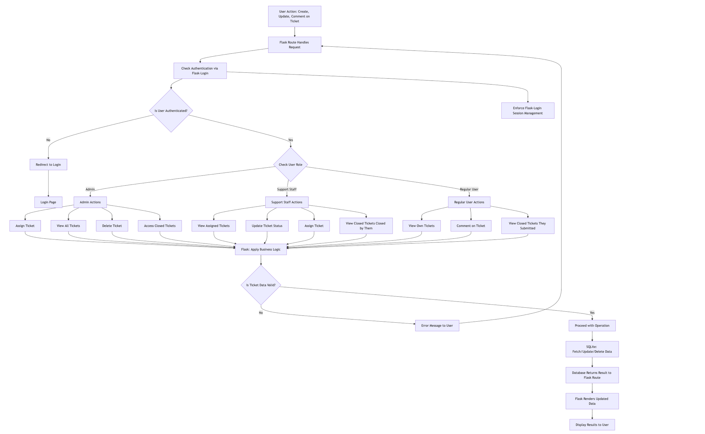
Figure 2 - Detailed Backend Flowchart

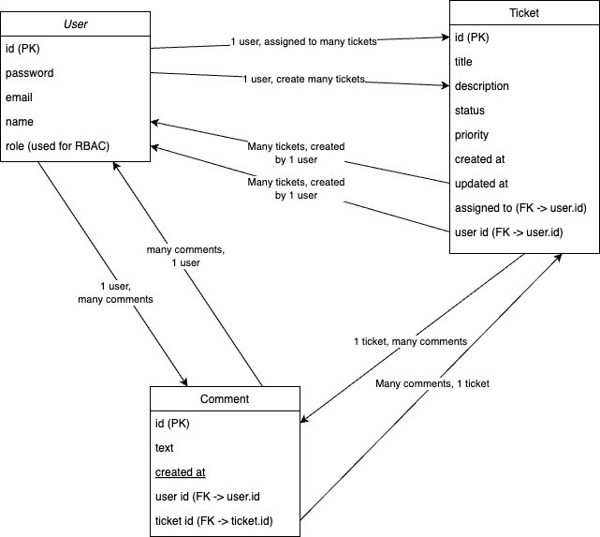
Entity Relationship Diagram
Figure 2 - Entity Relationship Diagram
Figure 3 - Entity Relationship Diagram

In this application, roles are managed through the role attribute in the User table. This field defines the user’s role (Admin, Support, or Regular User), and the application logic dynamically checks this field to restrict access and determine permissions. This solution is in line with agile principles. This method promotes simplicity and flexibility; by managing roles directly through the role attribute in the User table, we can deliver functionality that is effective and straightforward without overcomplicating the system with additional database structures that are unnecessary at this stage.

This method in addition promotes Iterative development and future scalability, now the system only requires three well-defined roles (Admin, Support, Regular User), and managing these through a single role attribute meets the current user needs. As the project evolves, additional roles or more complex permission structures can be implemented in future iterations, ensuring the system can scale without over-engineering at this stage.

RBAC is implemented by checking the role attribute of the user object in the Flask routes. For example, when an Admin accesses the ticket assignment page, the role attribute is checked to ensure only users with 'Admin' rights can assign tickets. Similarly, for Support users, the system restricts actions to those allowed for their role, like updating ticket statuses

Instruction on running the application
Included in README

Annotated Screenshots of the running application

Main page

Light mode
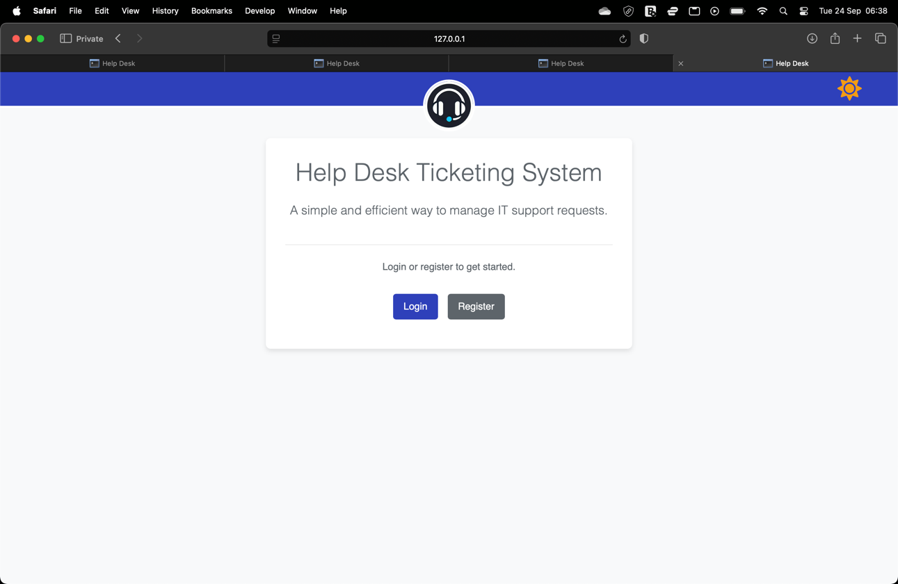
User to login or register
Site logo
Dark mode toggle

Dark mode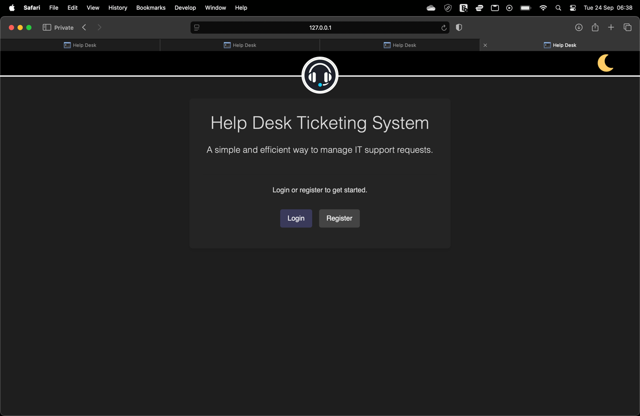
Dark mode Available on all pages

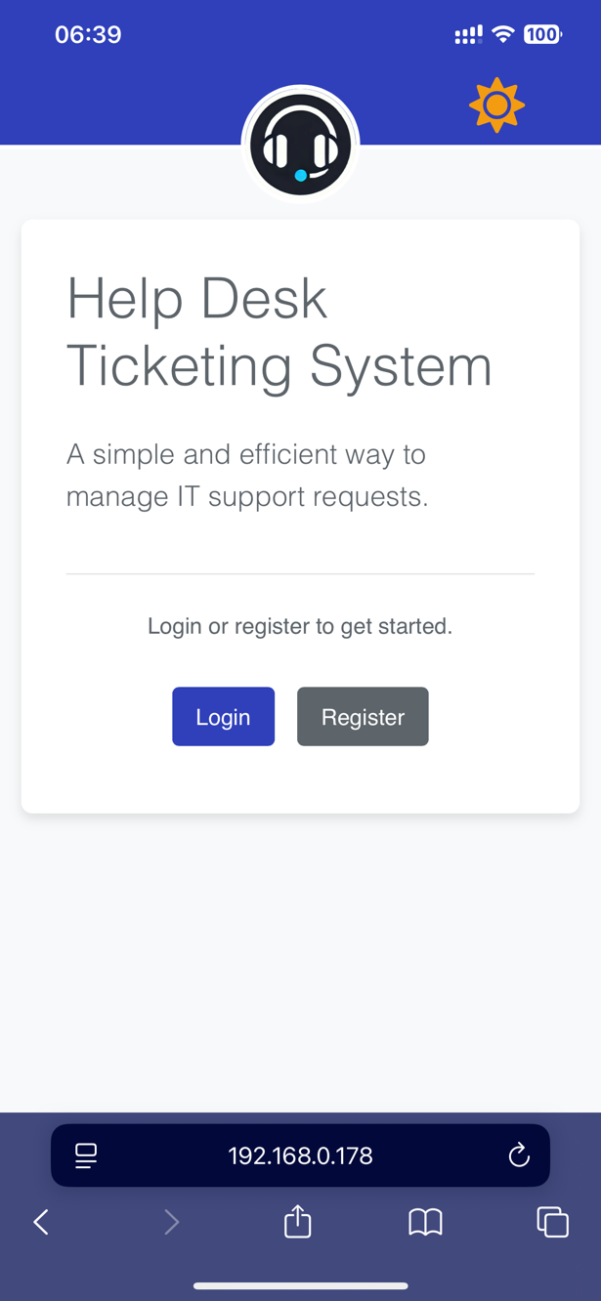
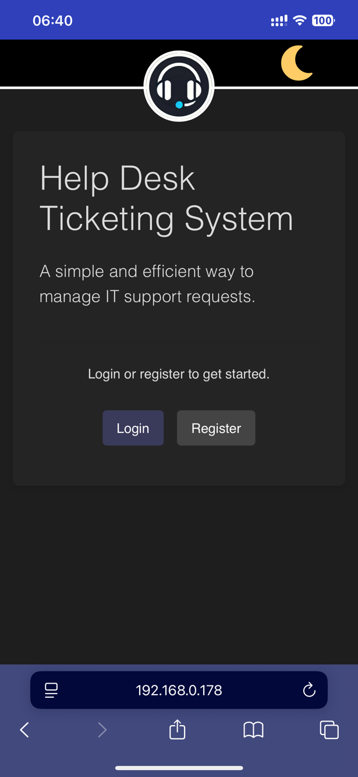
Mobile support for all pages in webapp

Login page
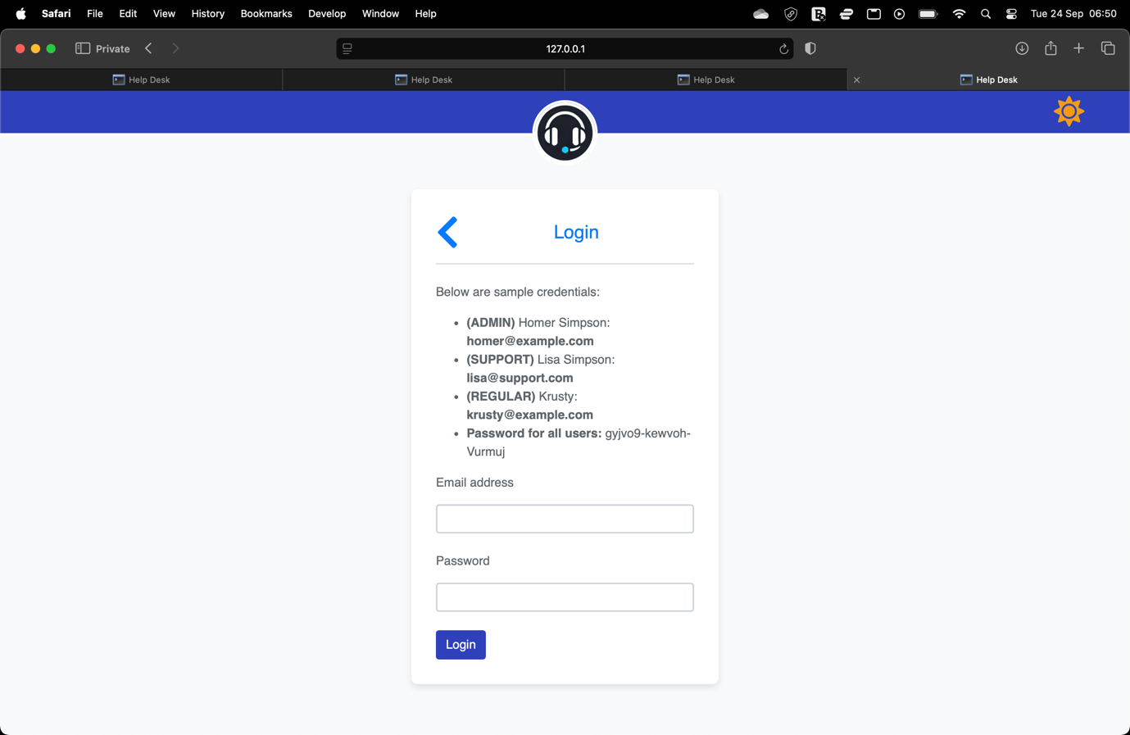
Validation for both fields
Sample credentials provided for marking purposes only, in an actual webapp credentials would not be made so public like this.

Login page dark mode
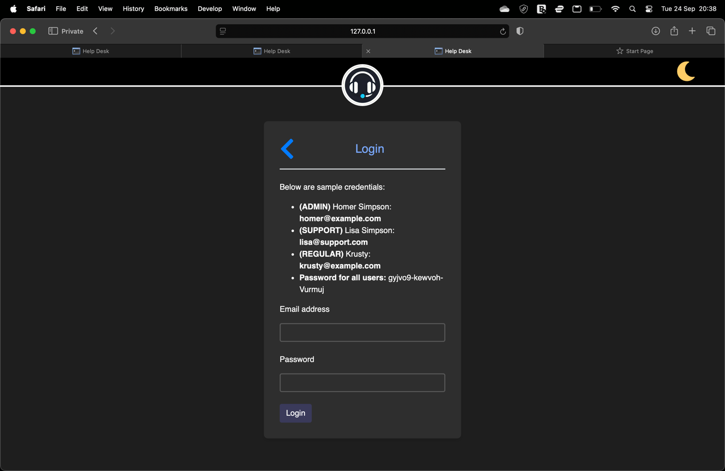
Example of night mode

Register page
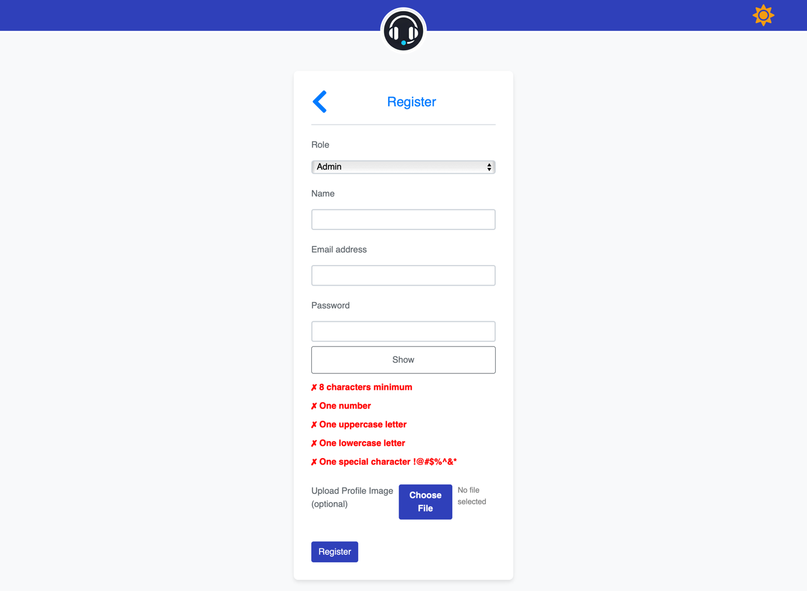
Optional profile image upload
All fields have validation

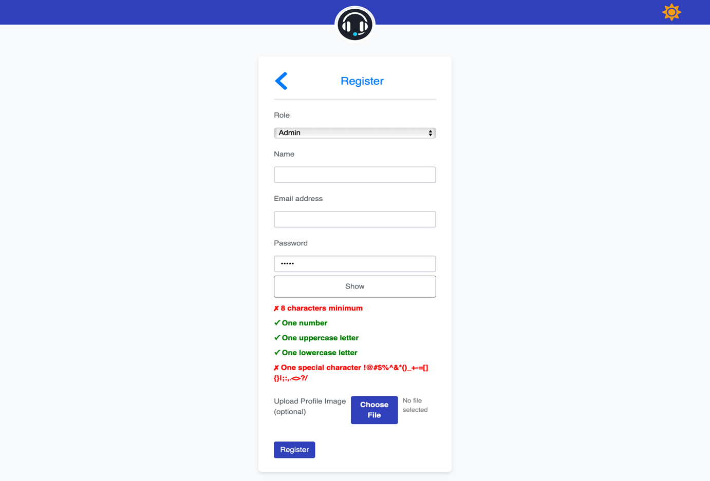
For user convenience, met criteria are highlighted green as they are met

Admin all tickets page
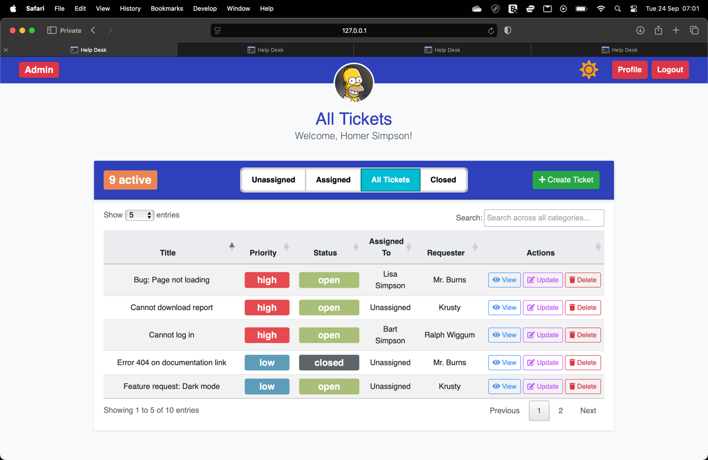
Search bar searches though all categories as words are types
Pagination
View for marking purposes only
Red role badge for Admin
Control entries per page
Admin exclusive page
Profile image
Able to sort through tickets
Active ticket count that updates colour depending on number of open/in-progress tickets

Admin all tickets page dark mode
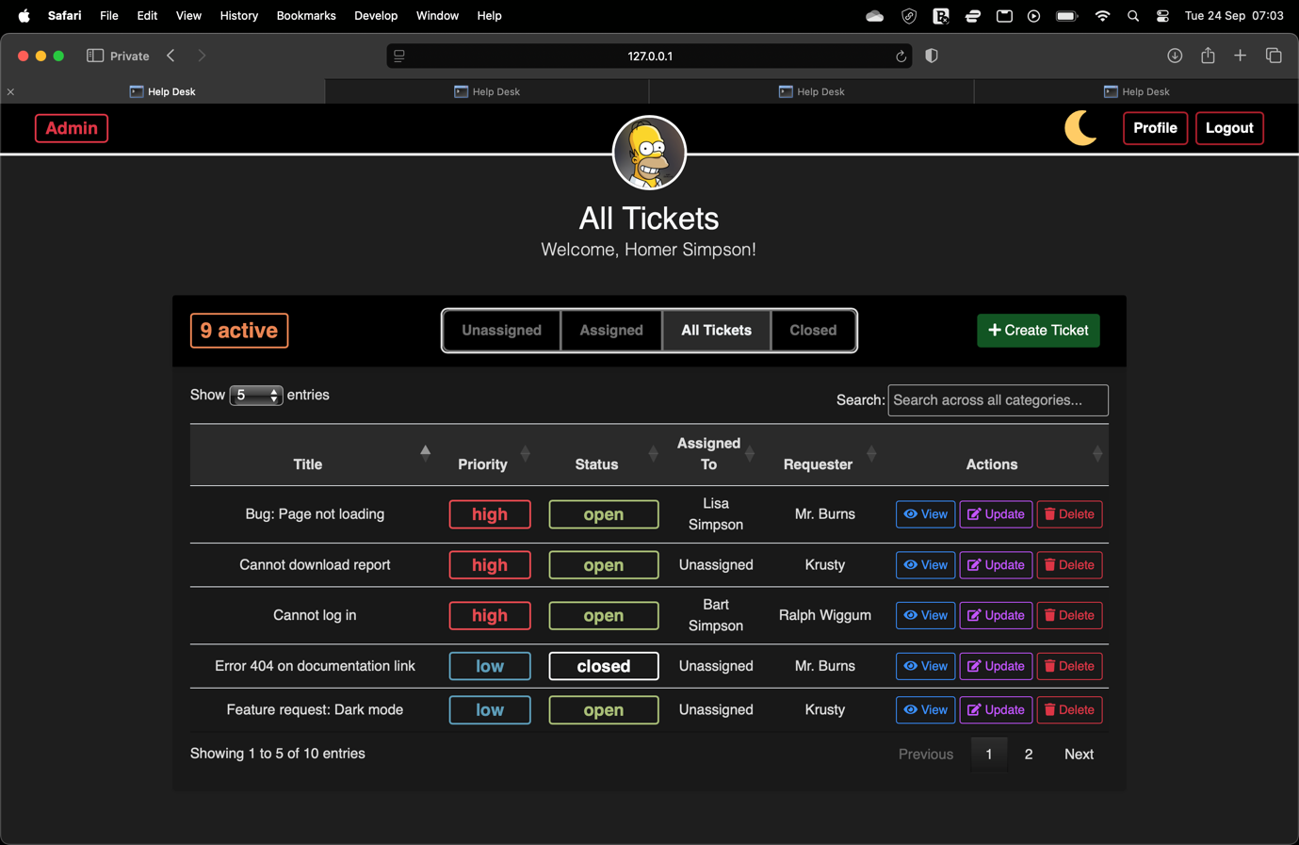
Example of night mode

Admin all tickets page on mobile
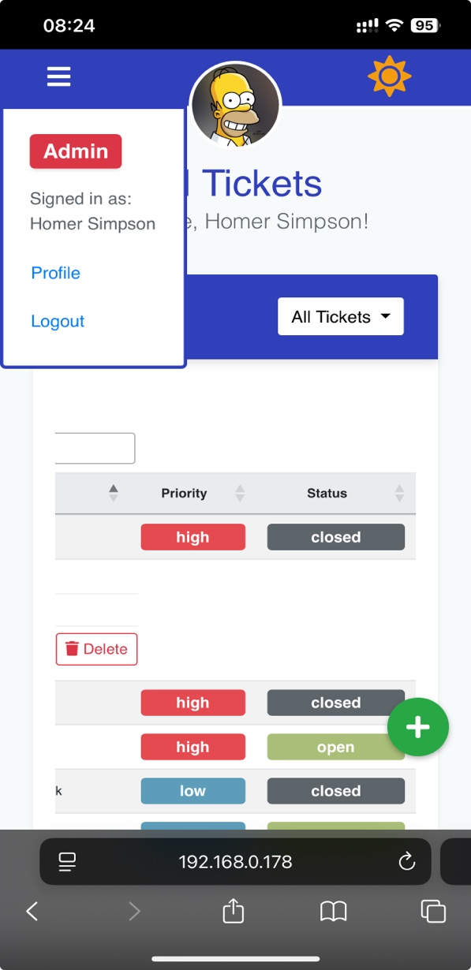
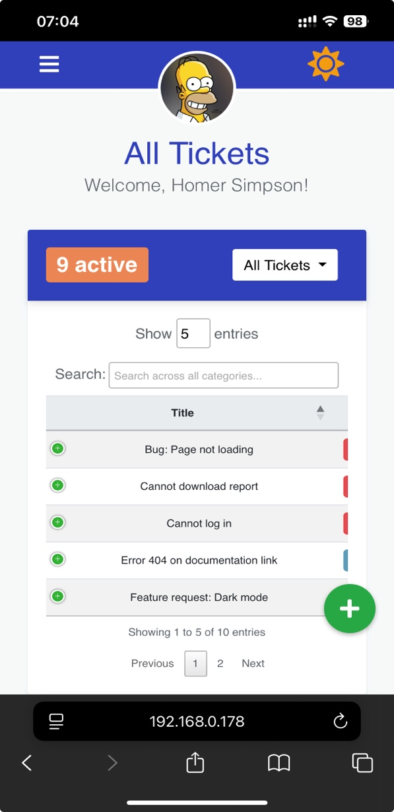
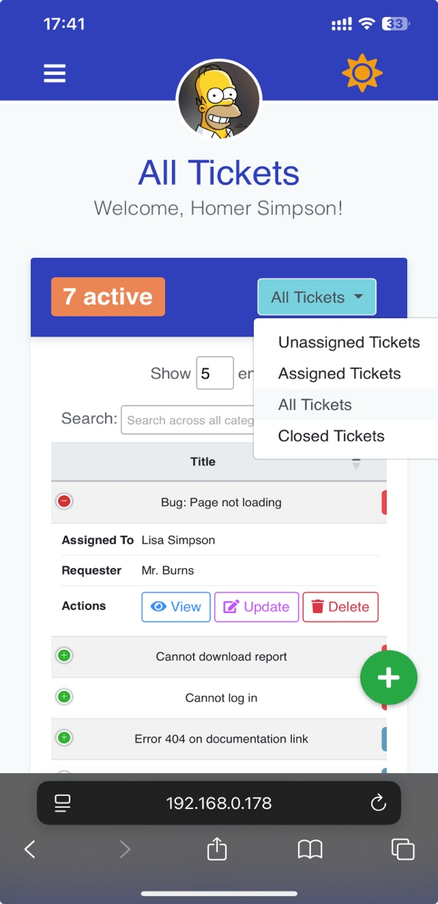
Priority and status can be viewed by scrolling horizontally
Select which page through dropdown
Hamburger menu opens a dropdown with navbar buttons
Expanded view of row
All controls that are available for Admin are available on mobile mode
Create ticket button is a floating action button
Mobile mode has collapsed rows that can be expanded with this button

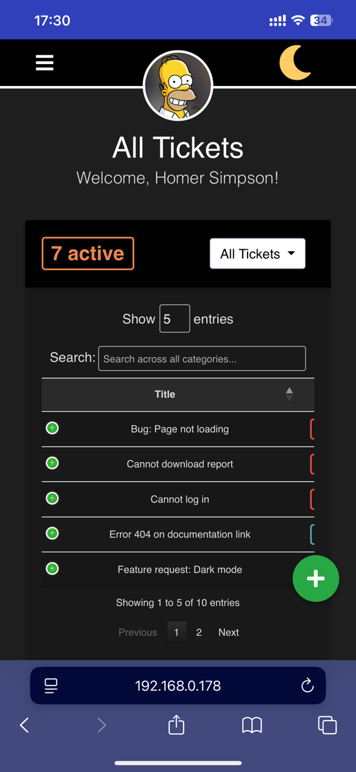
Admin all tickets page on mobile dark mode
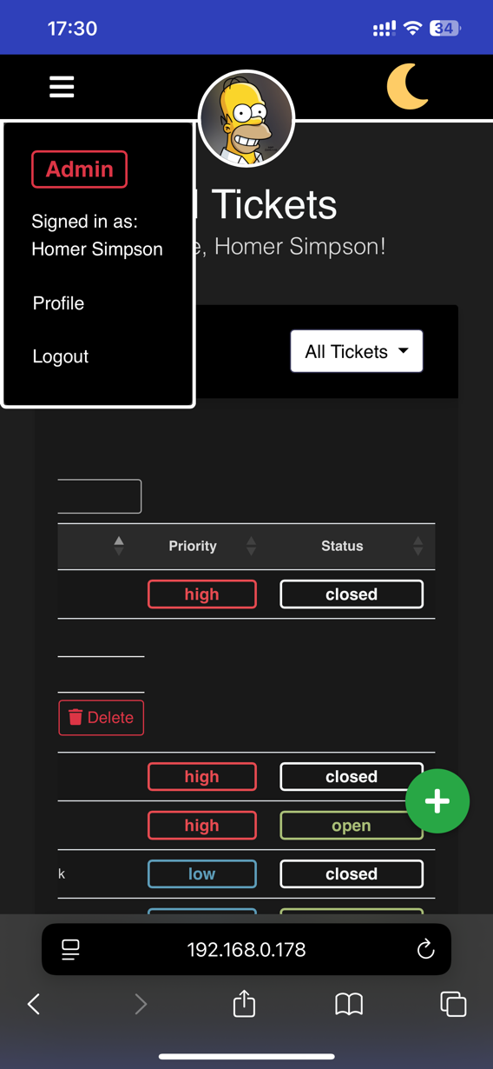
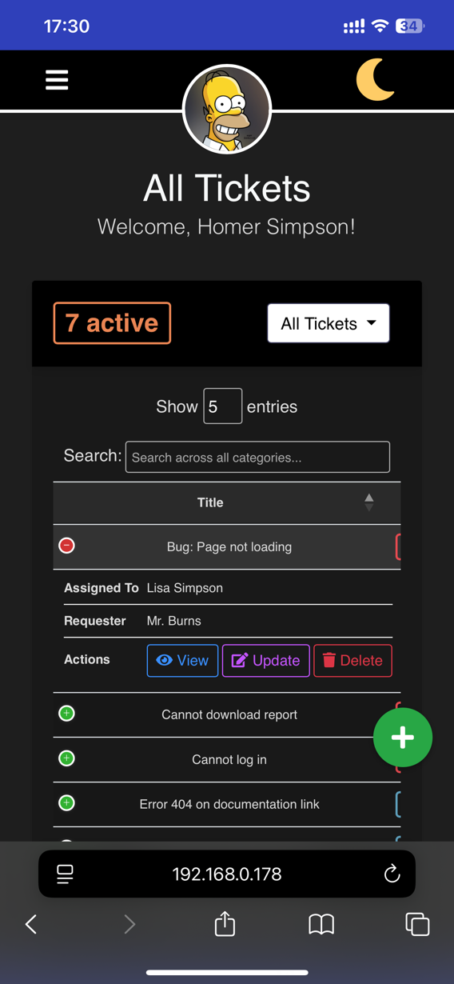
Dark mode version of the pages

Support assigned tickets page
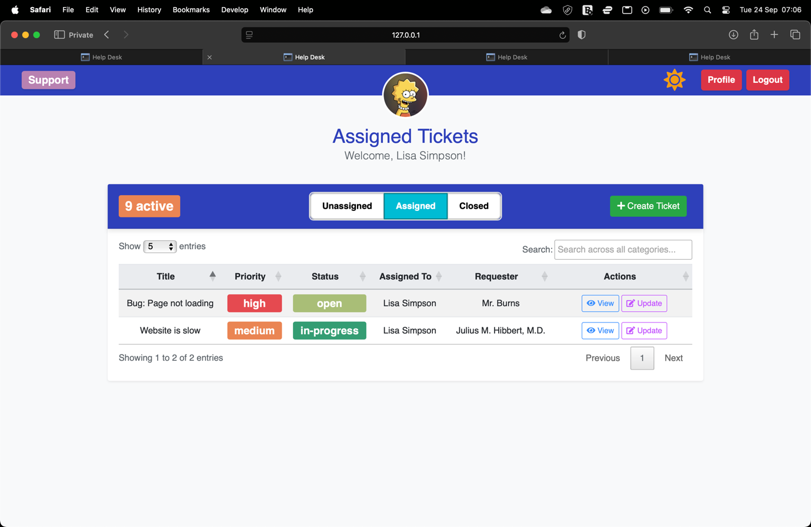
Purple role badge for Support
Assigned page for support users will show tickets that are assigned to the support user

Support assigned tickets page night mode
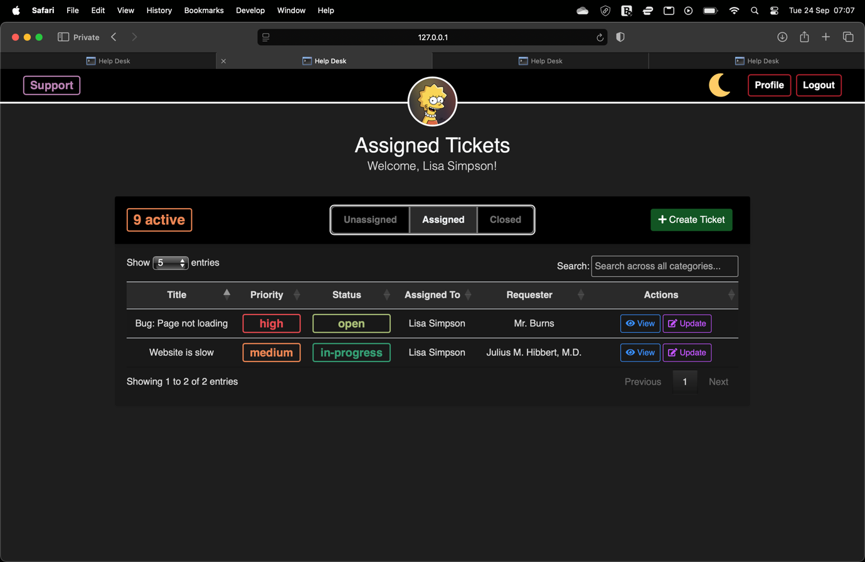
Example of night mode

Support all tickets page on mobile
All controls that are available for Admin are available on mobile mode
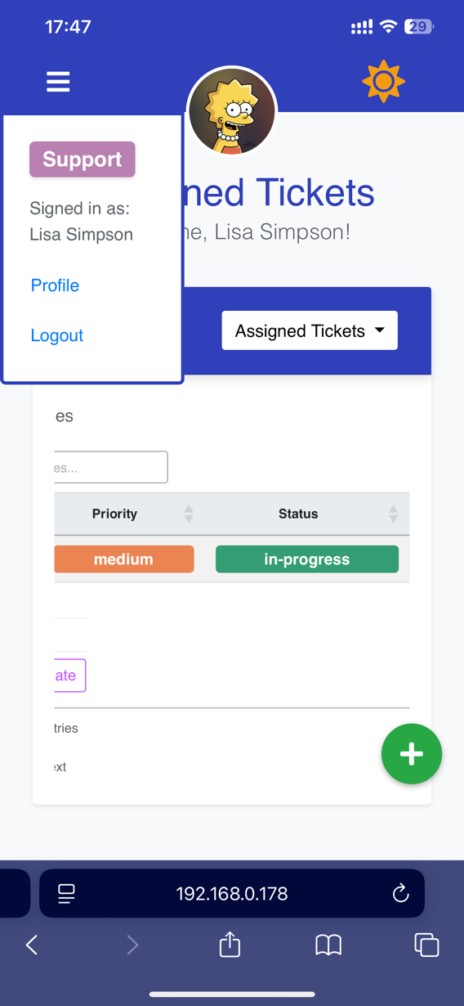
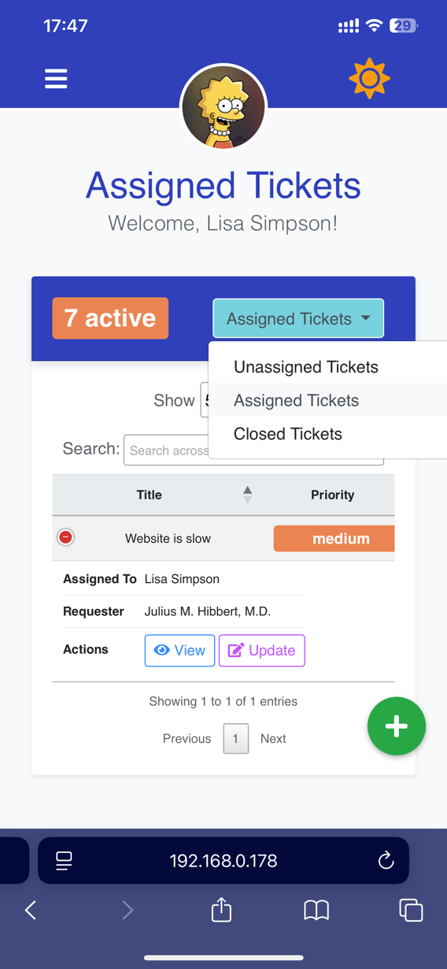
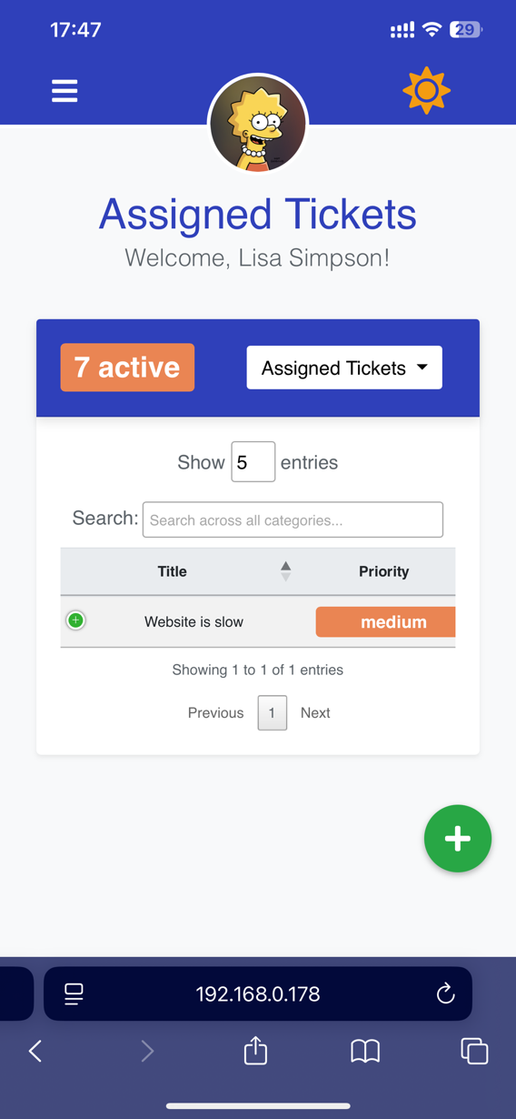

Support all tickets page on mobile dark mode

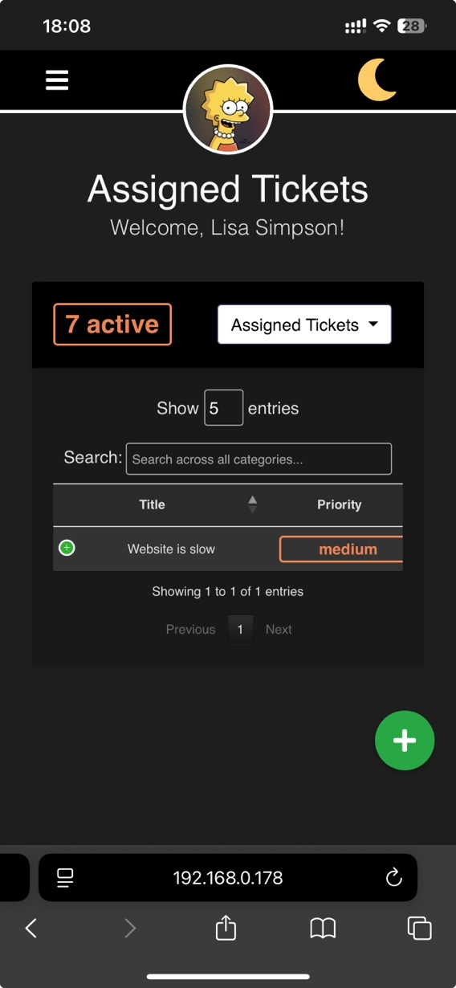
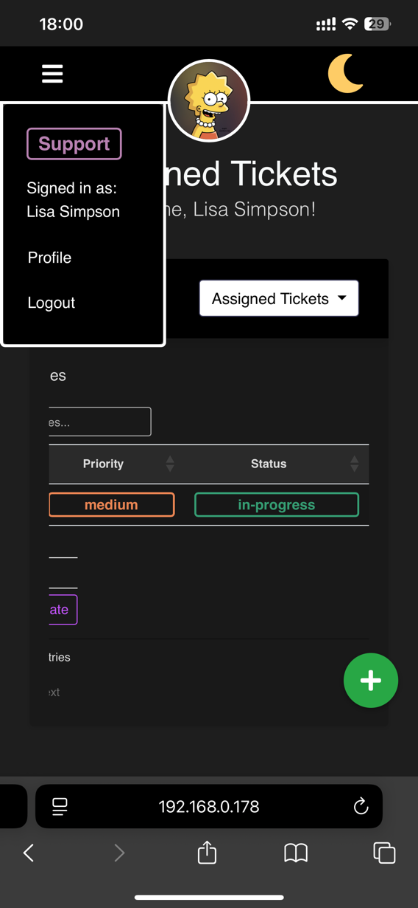
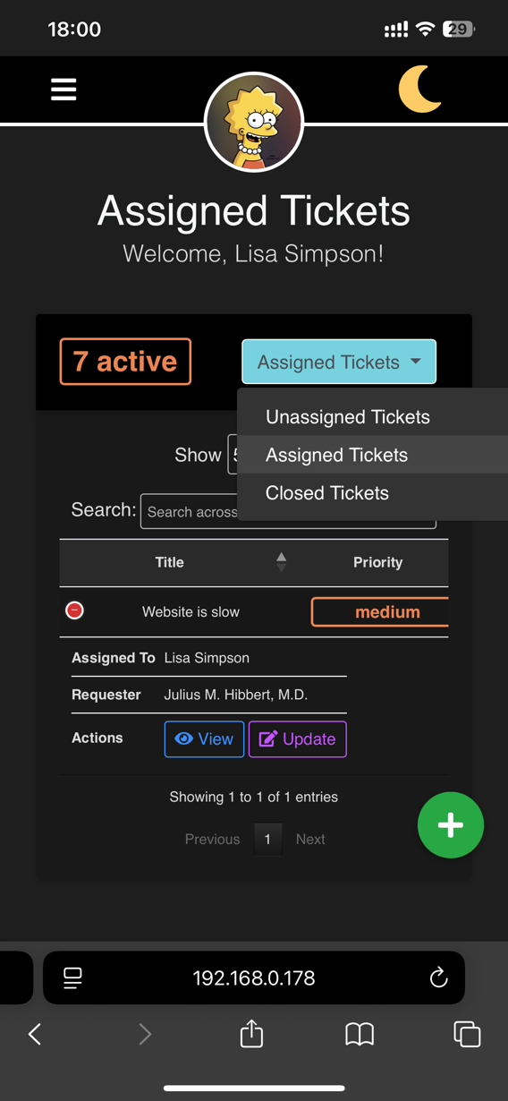
Support all tickets mobile pages, night mode example

Regular user active tickets page

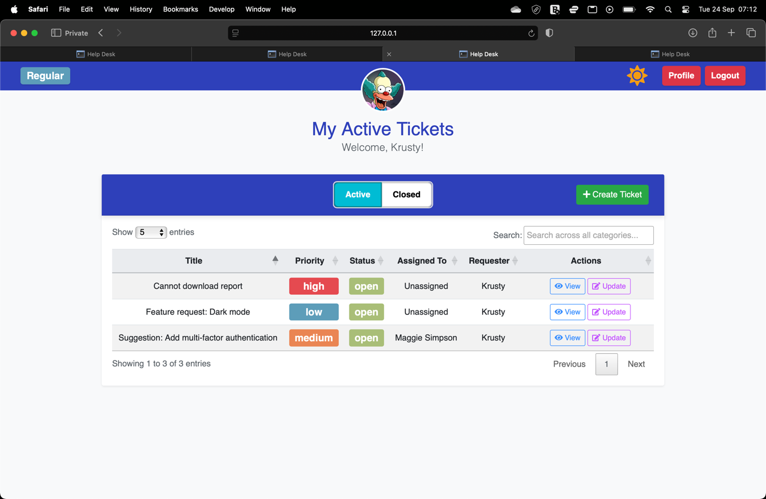
Regular users can only view Active (open/in-progress) tickets that either they had created or they are marked as requester by the support/admin user that created the ticket
Blue role badge for Regular user

Regular user active tickets page night mode
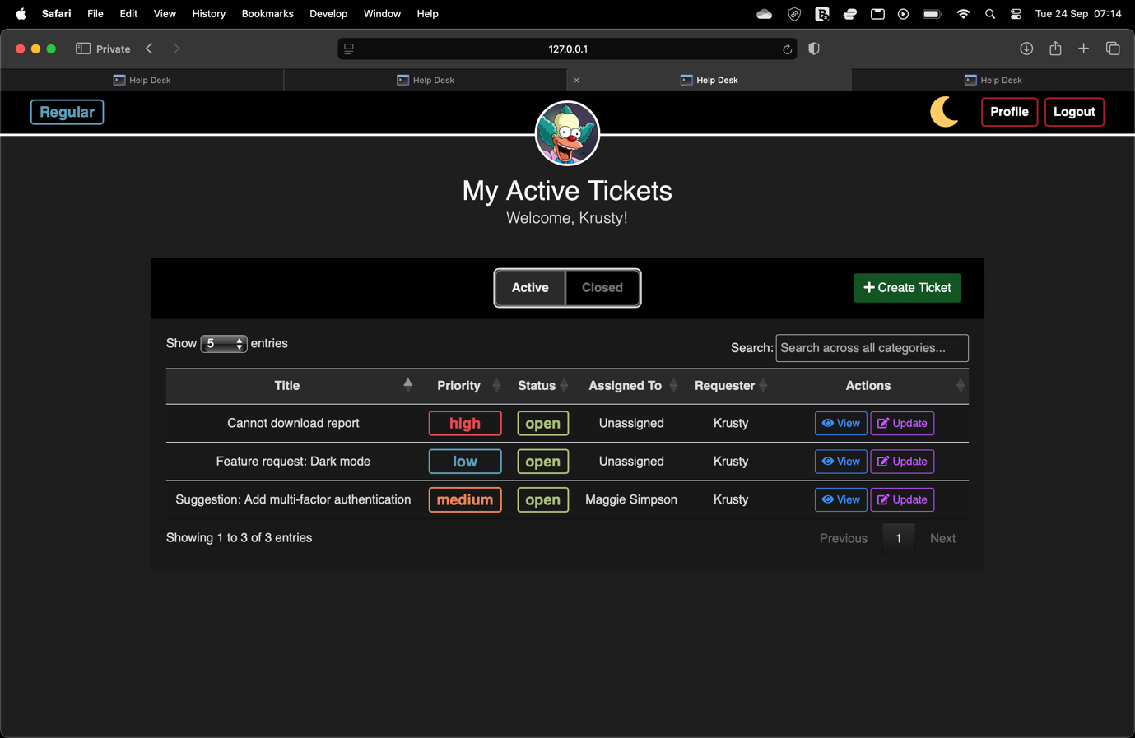
Example of night mode

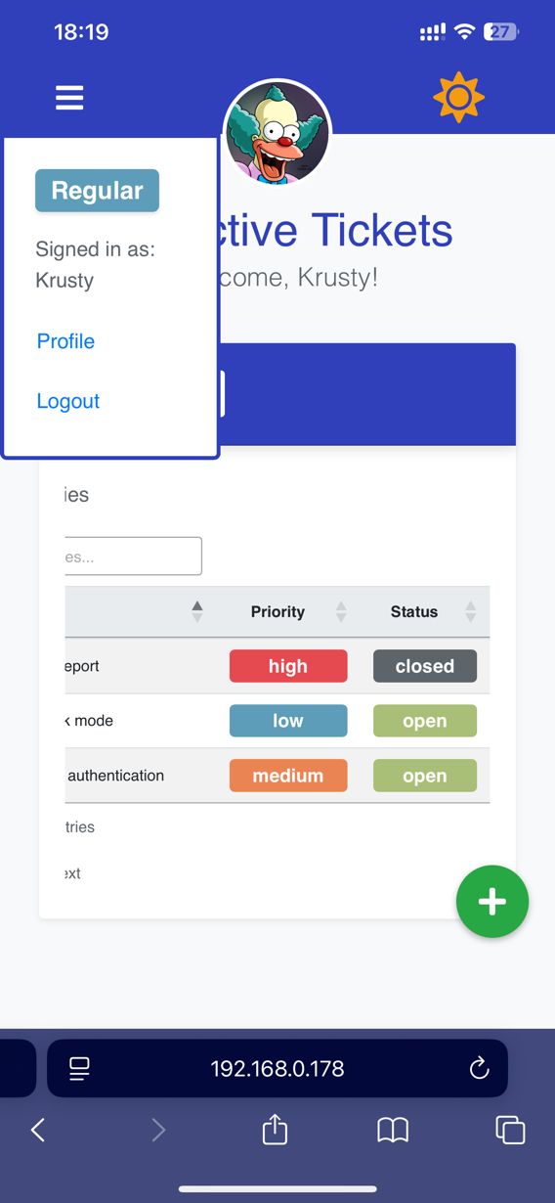
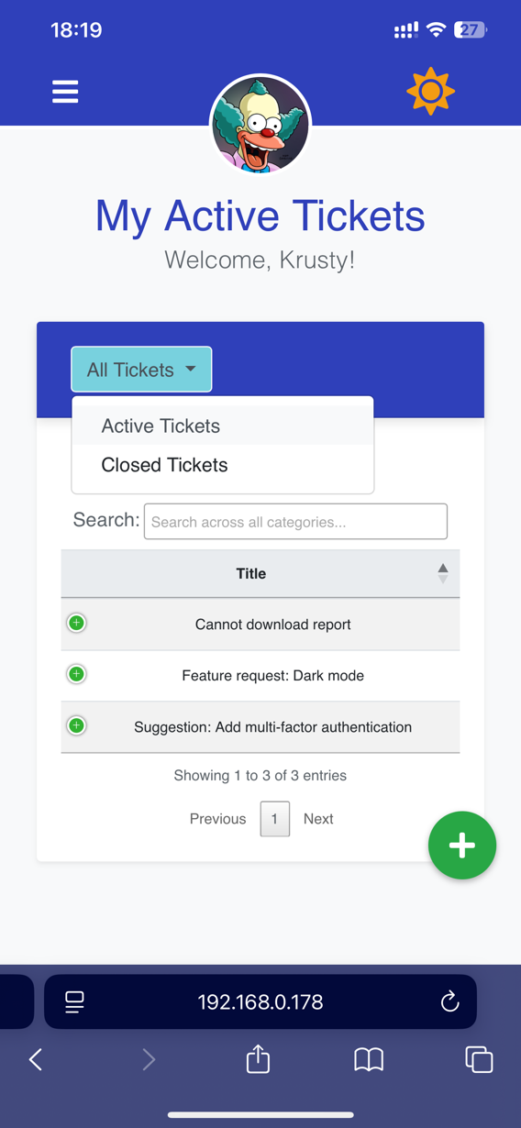
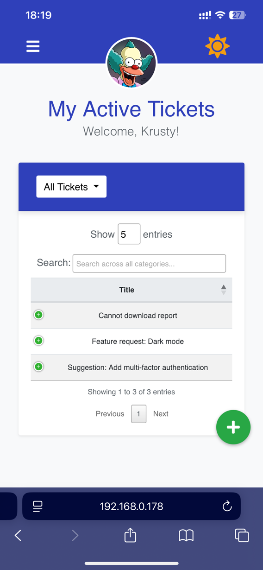
Regular active tickets page on mobile
All controls that are available for Admin are available on mobile mode

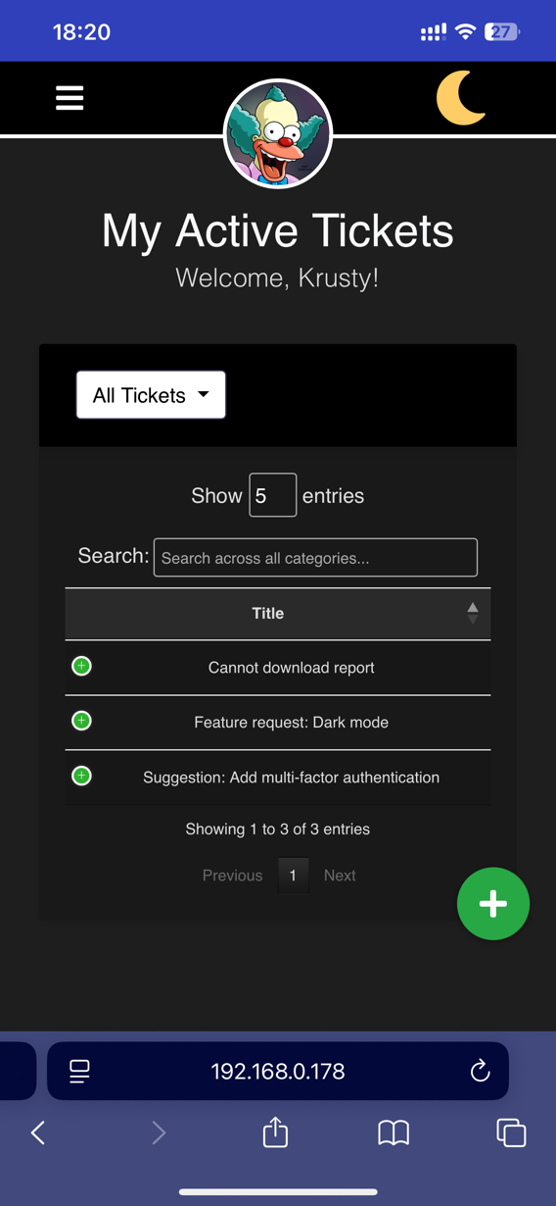
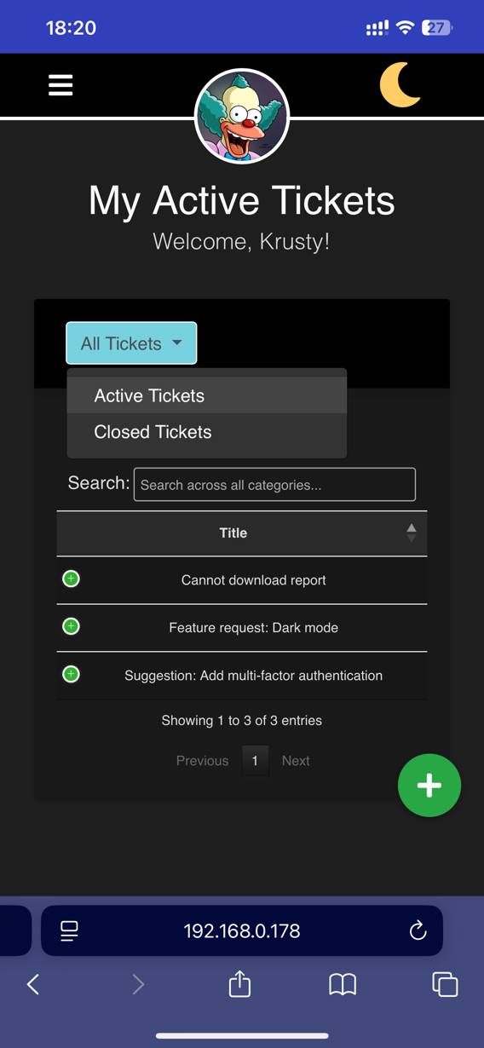
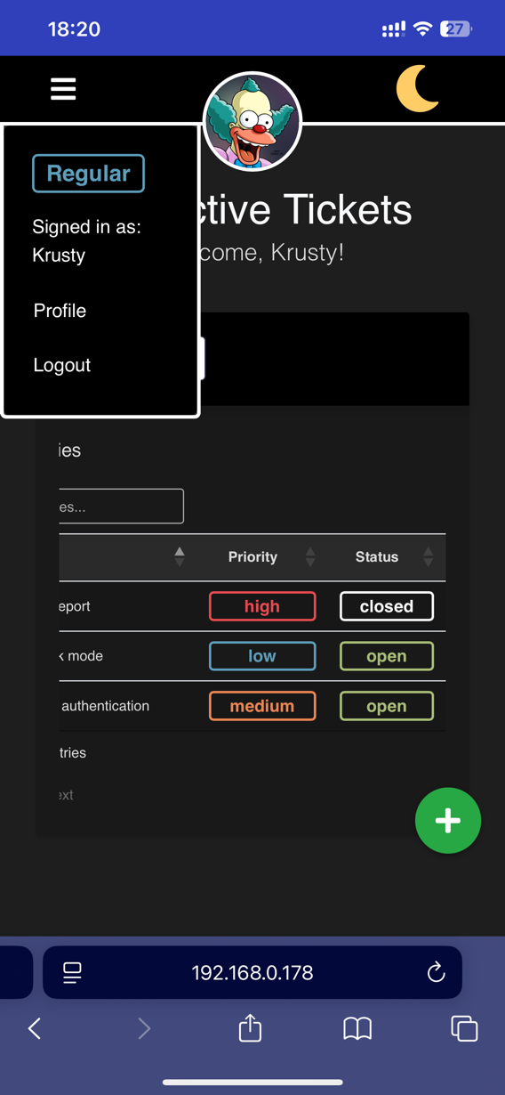
Regular active tickets page on mobile dark mod
Support all tickets mobile pages, night mode example

Admin user unassigned tickets page
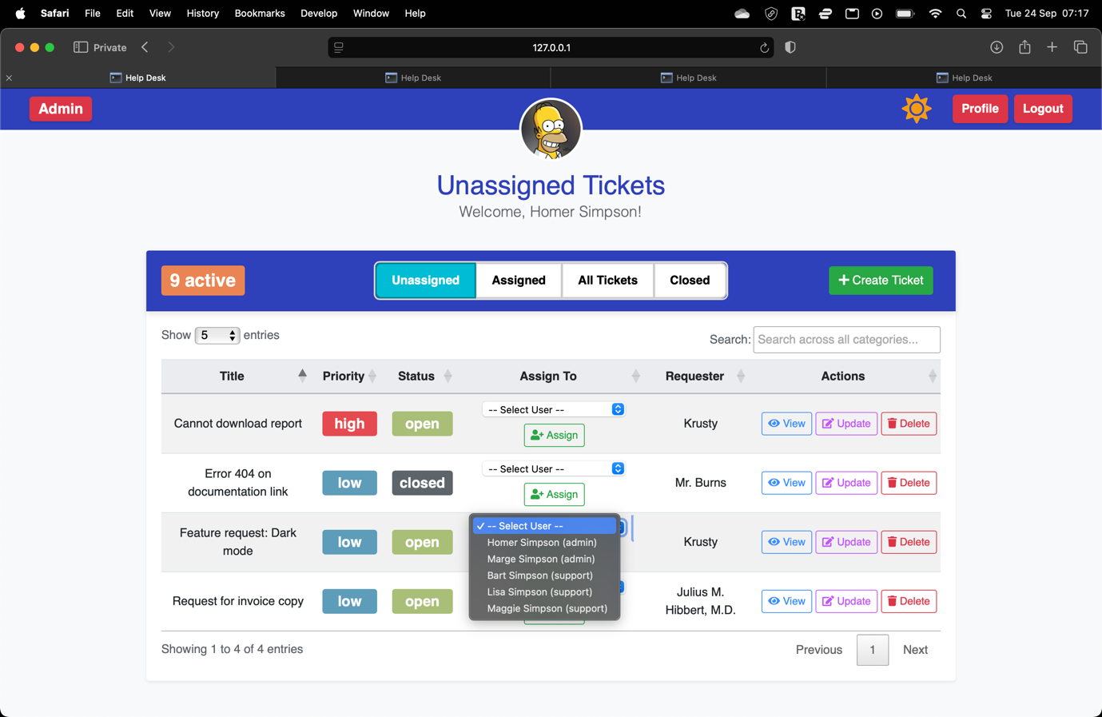
Dropdown and assign button for admin convenience, useful for a standup scenario where tickets are assigned by admin to themselves or other support users

Admin user assigning ticket on unassigned tickets page flash message
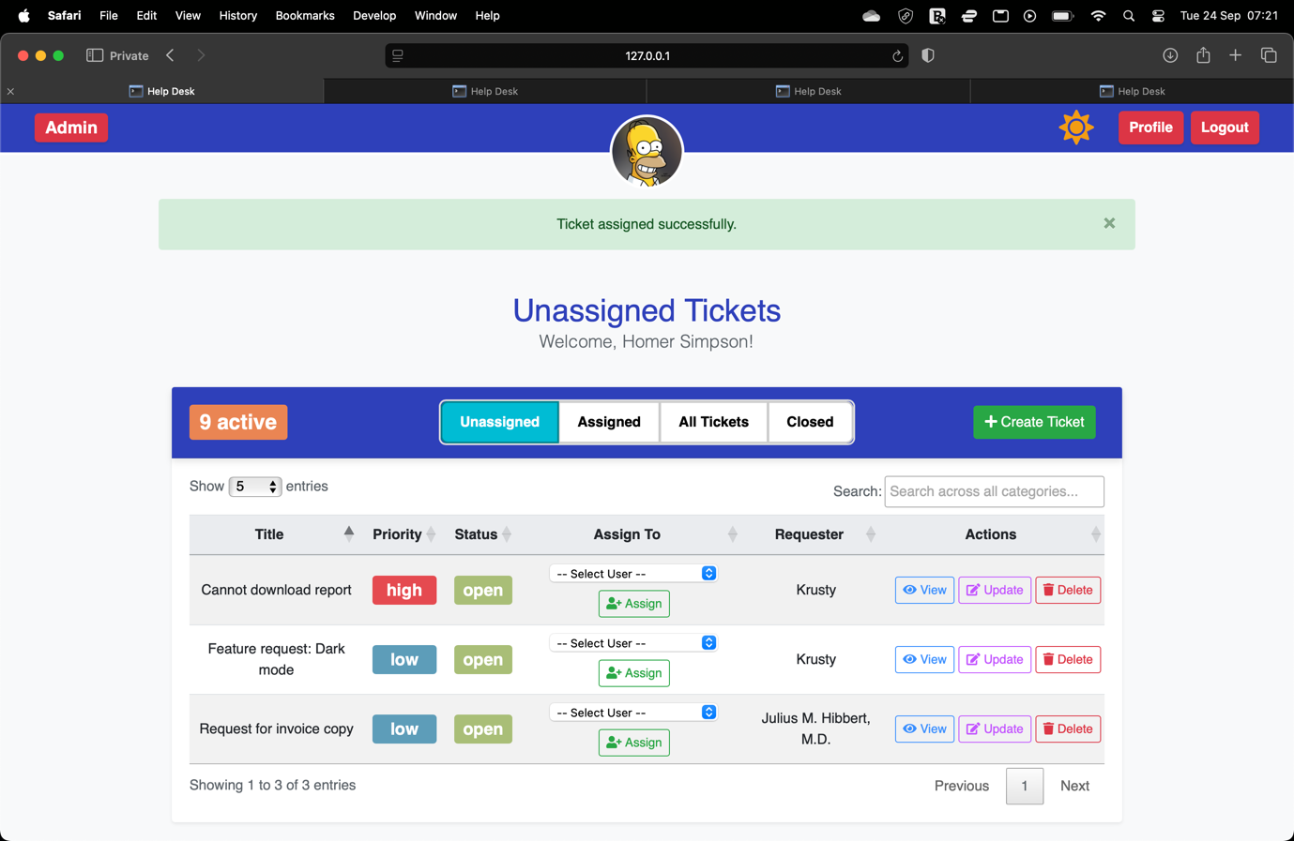
Flash message when ticket assigned

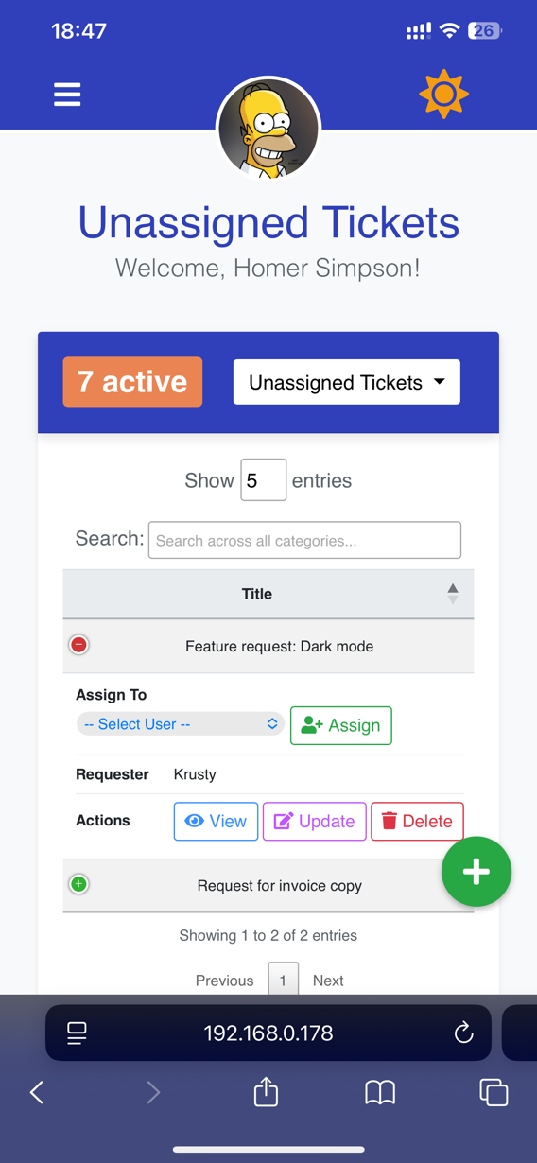
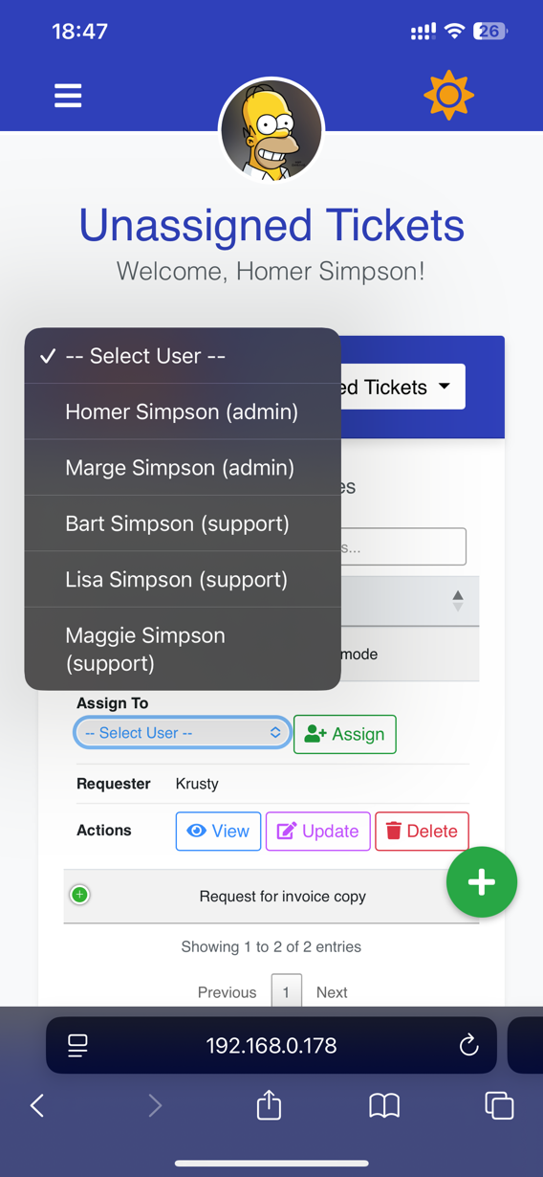
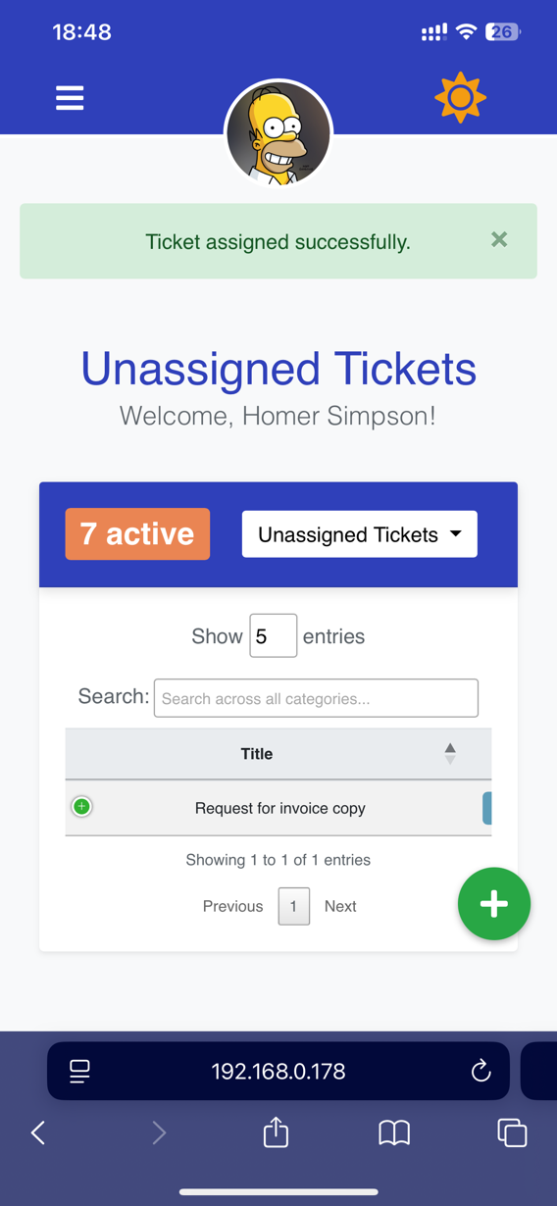
Admin unassigned tickets page on mobile
Flash message on mobile
Mobile dropdown for support user to assign ticket to
Assign button is located in expanded view on mobile

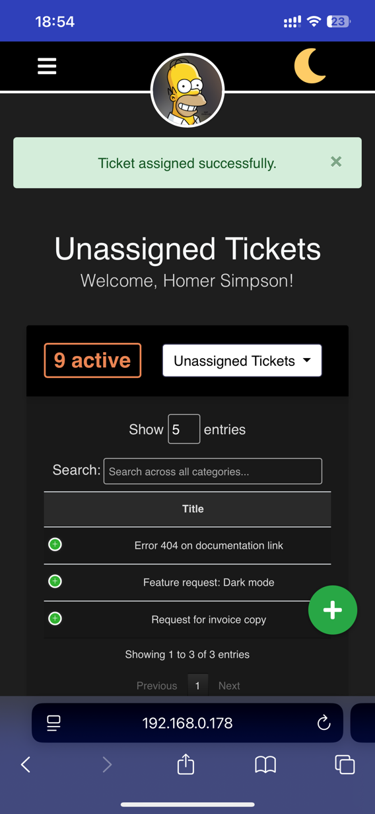
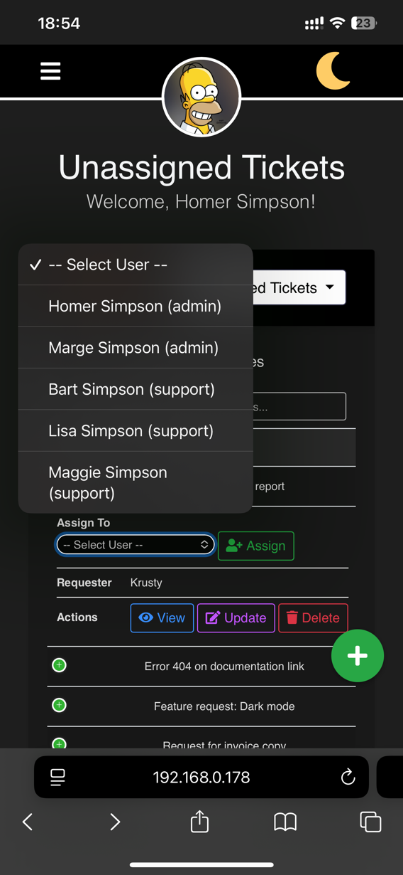
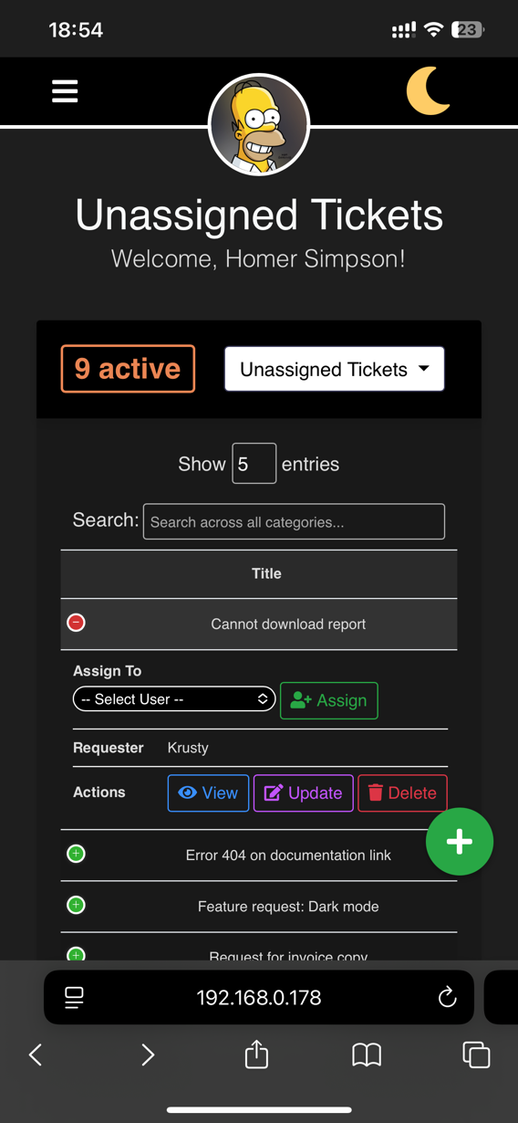
Regular active tickets page on mobile dark mode
Admin unassigned tickets mobile pages, night mode example

Admin user assigned ticket page
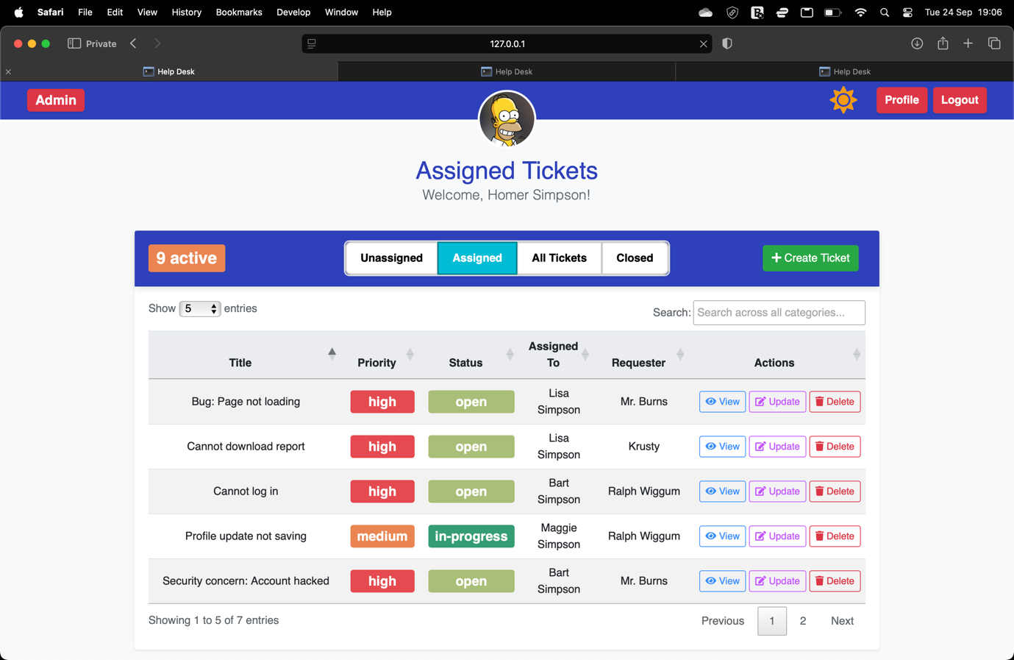
Assigned tickets page for admin will show all tickets that are assigned to support users, excluding ticket with closed status

Admin user assigned ticket page
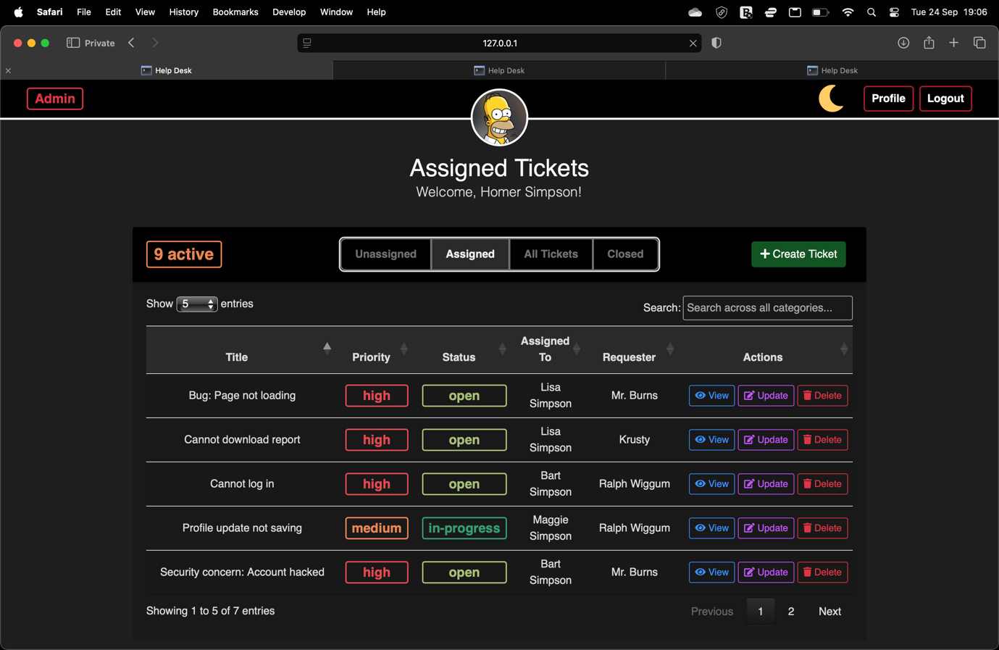
Dark mode for assigned ticket page

Admin user closed ticket page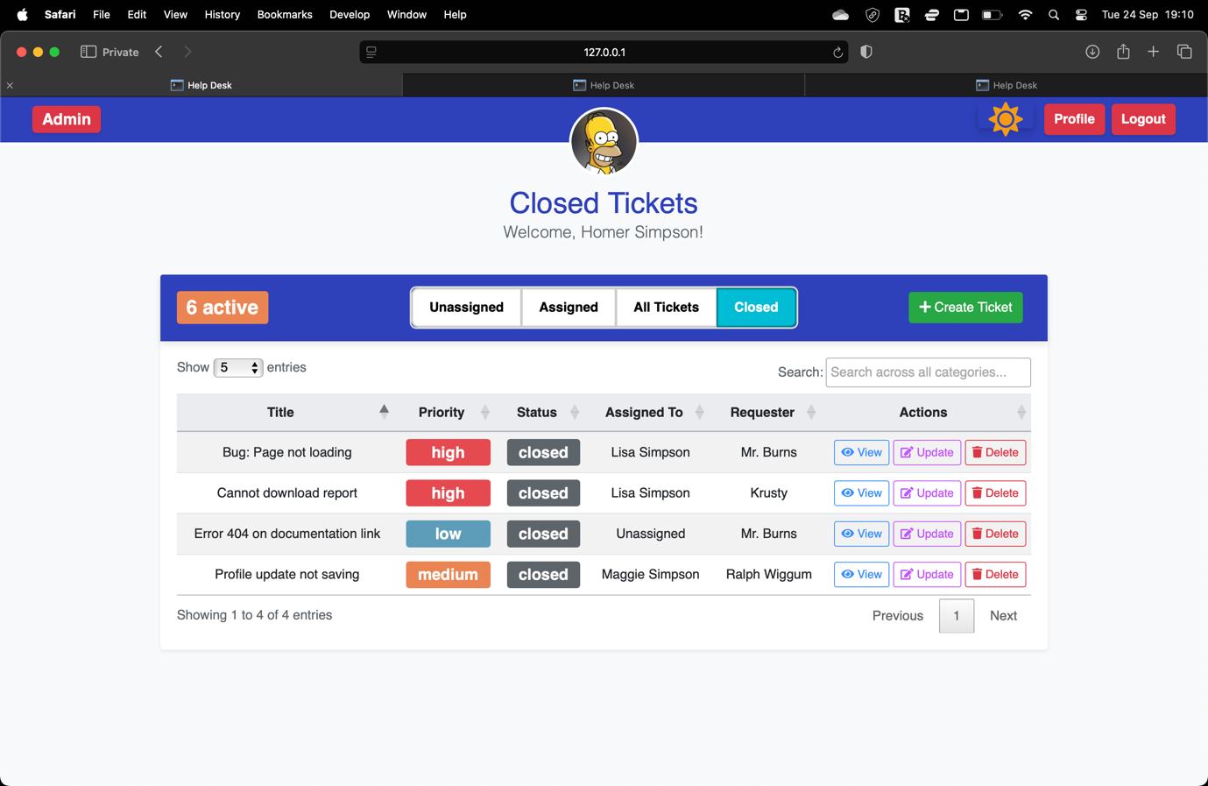
Closed tickets page for admin will show all tickets that have closed status, regardless of assignee status

Admin user closed ticket page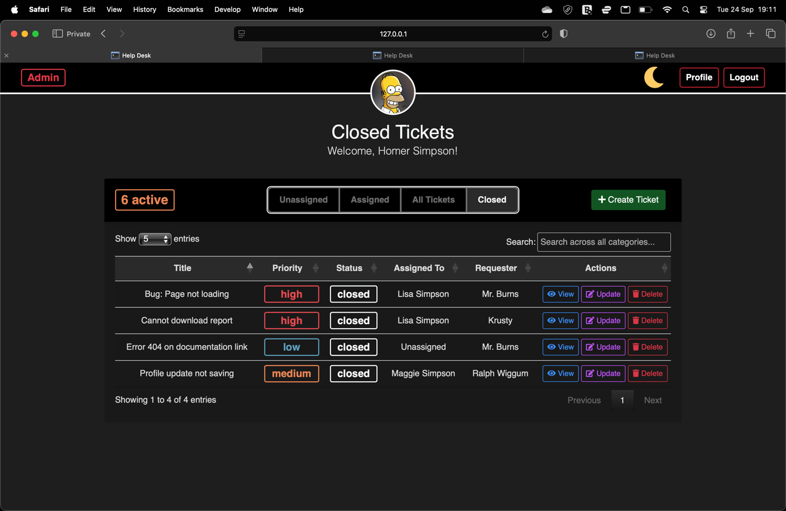
Dark mode for closed ticket page

Support user unassigned ticket page
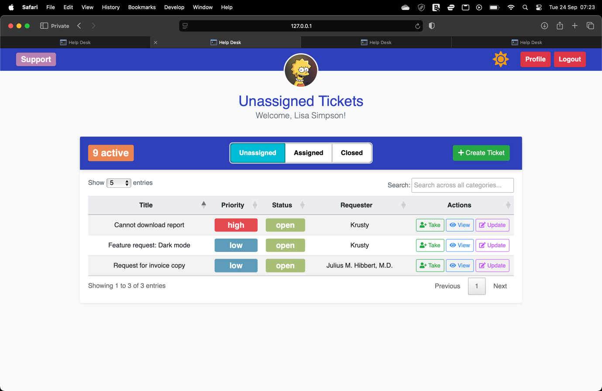
Unassigned tickets page will show support users available tickets to take, “Take” button will allow the user to one-click assign the ticket to themselves

Support user closed ticket page
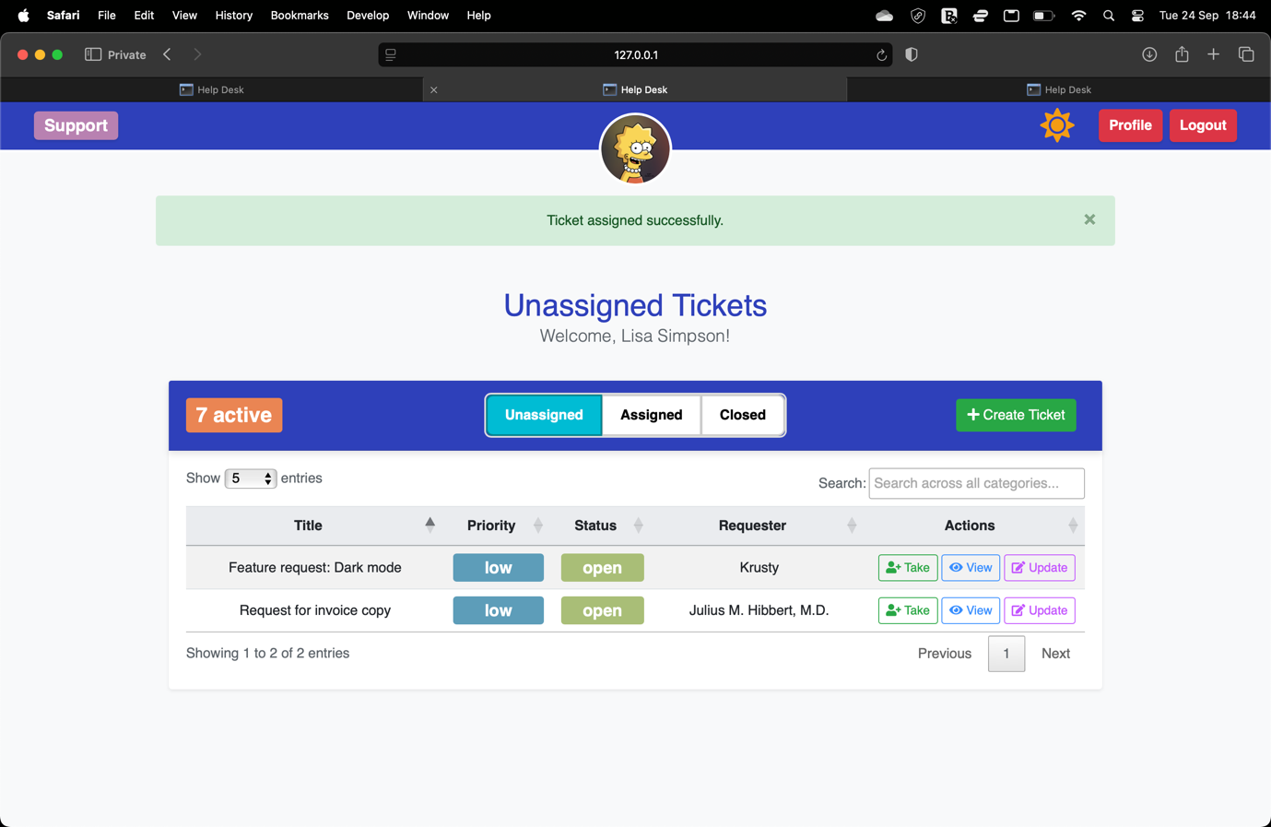
Flash message when ticket taken

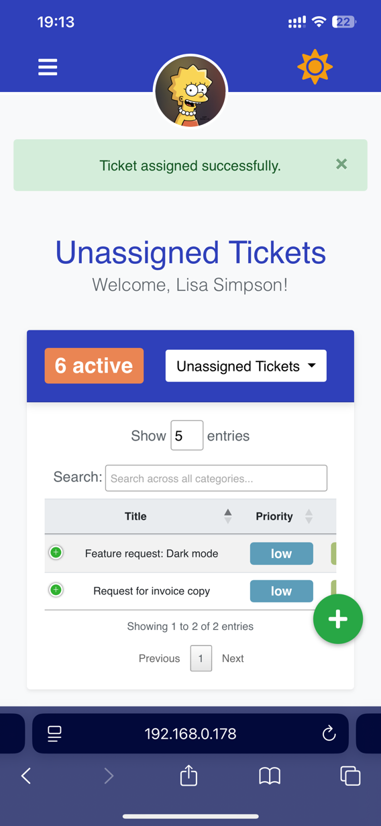
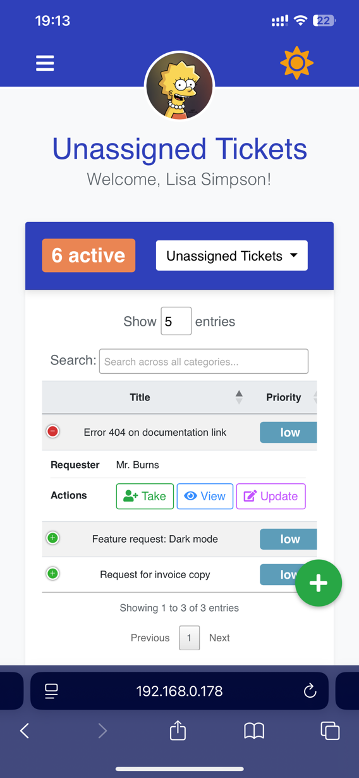
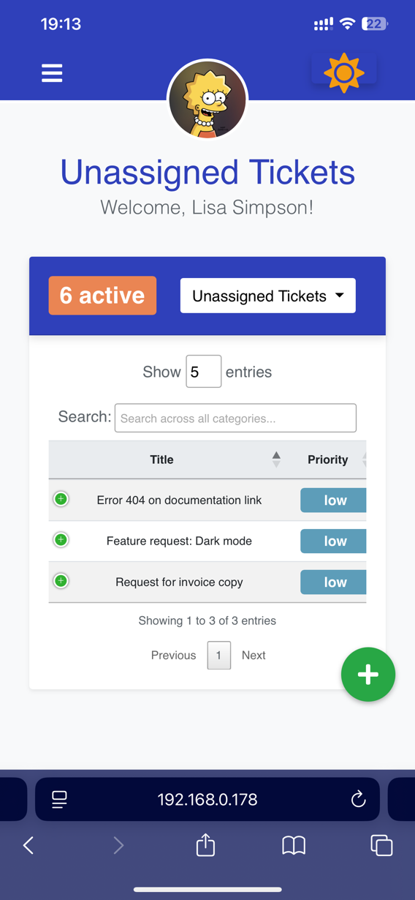
Support unassigned tickets page on mobile
Flash message on mobile
Unassigned tickets view on mobile
Take button locating inside expanded row

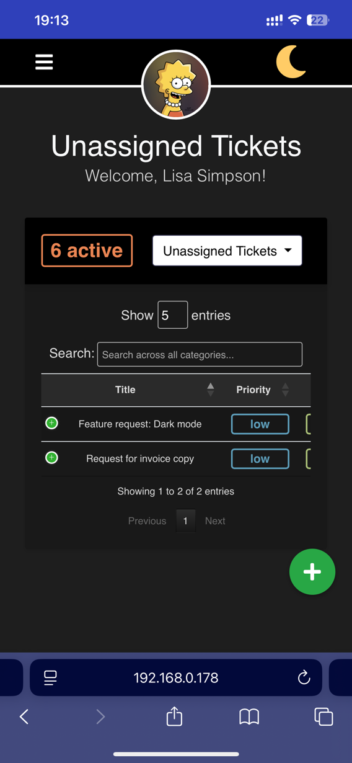
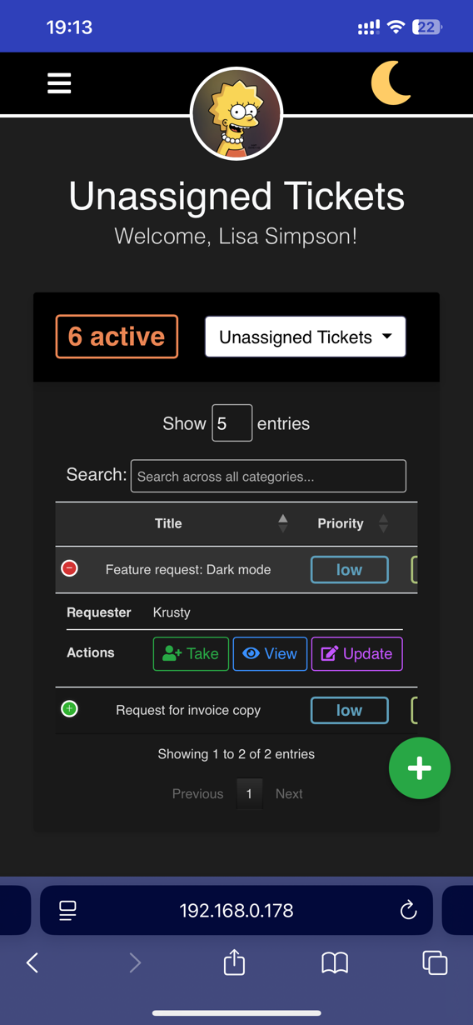
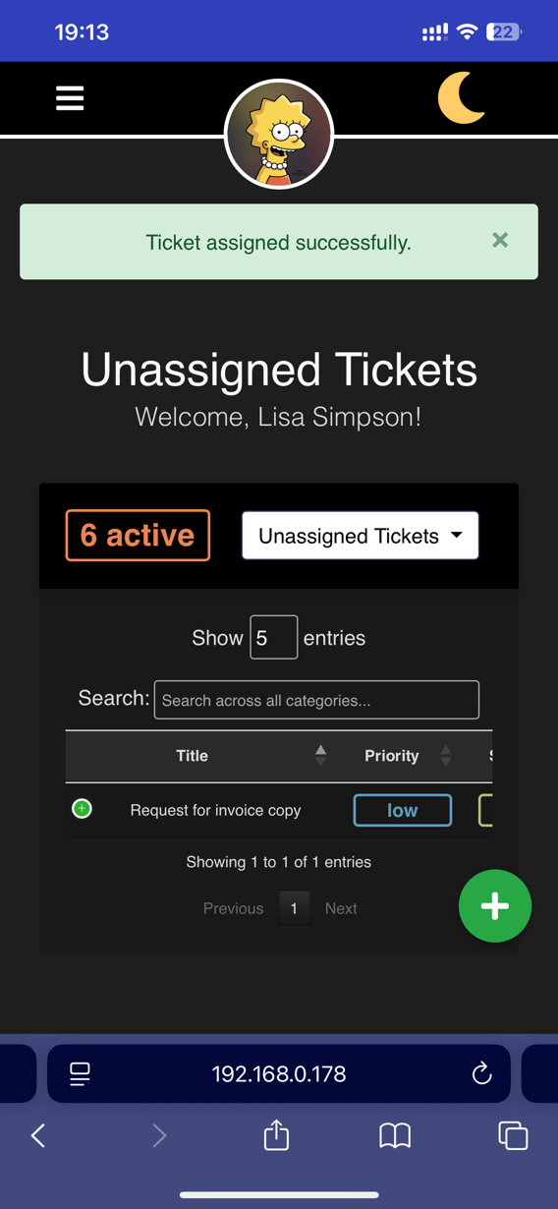
Support unassigned tickets page on mobile dark mode
Support user unassigned tickets mobile pages, night mode example

Regular user active ticket page
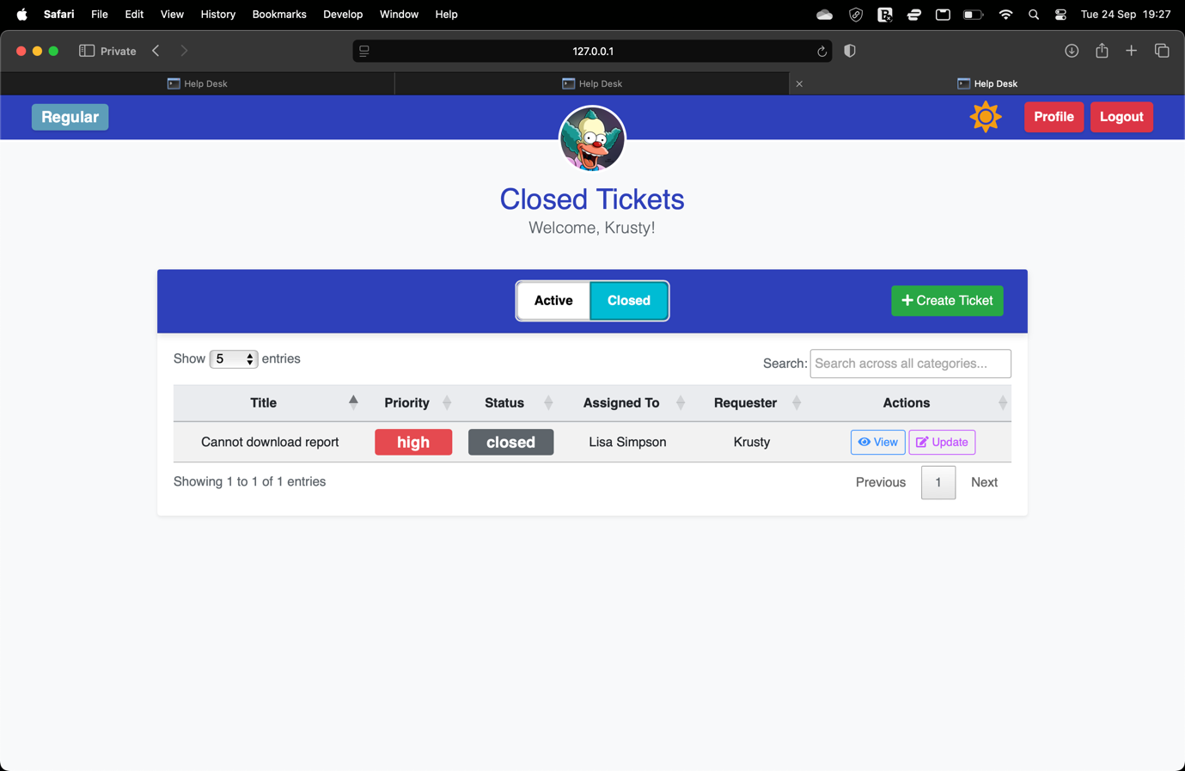
Regular users view tickets that they had submitted that are now marked closed

Regular user closed ticket page
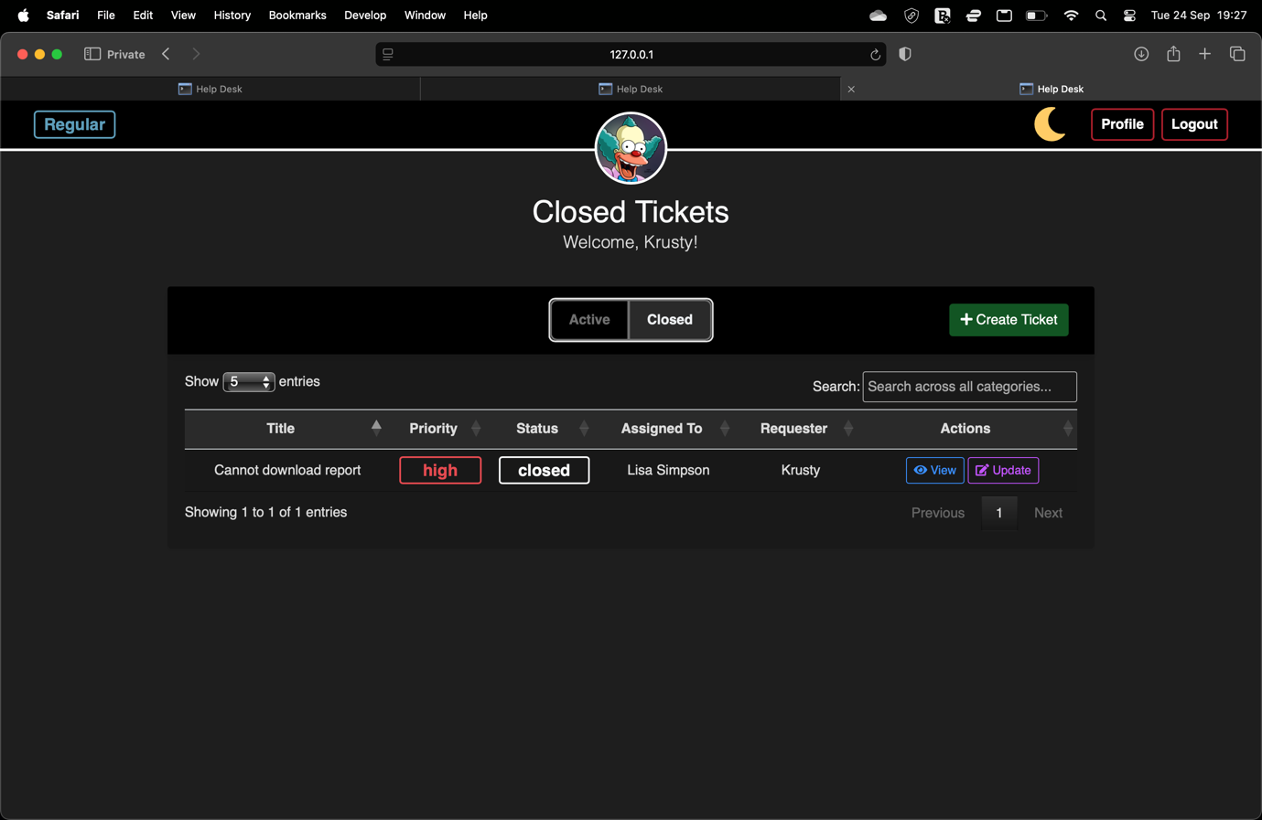
Dark mode for closed ticket page

Admin user create ticket page
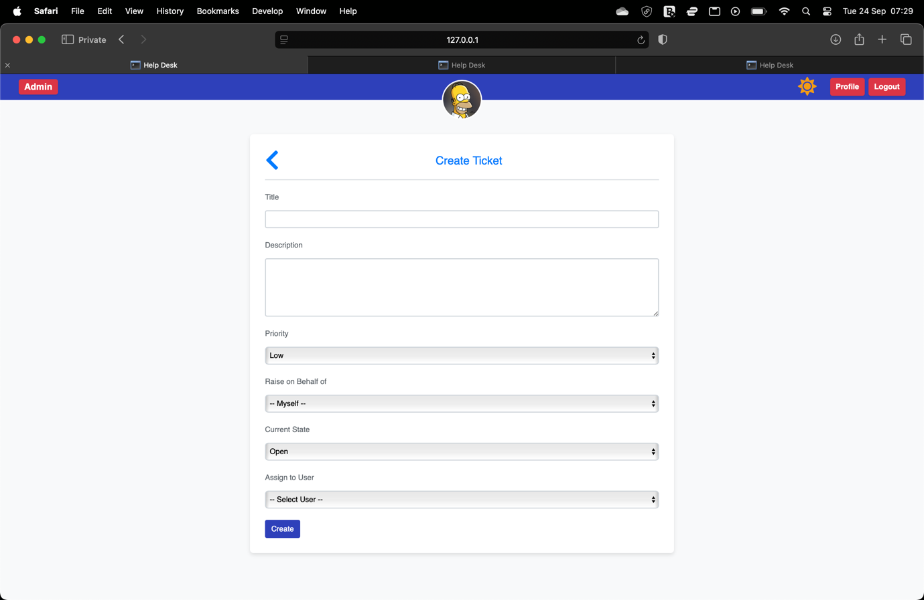
Admin users can create tickets and edit all ticket attributes:
- Title
- Description
- Priority
- Submitter (Raise on behalf of)
- State
- Support user (Assign to user)

Support user create ticket page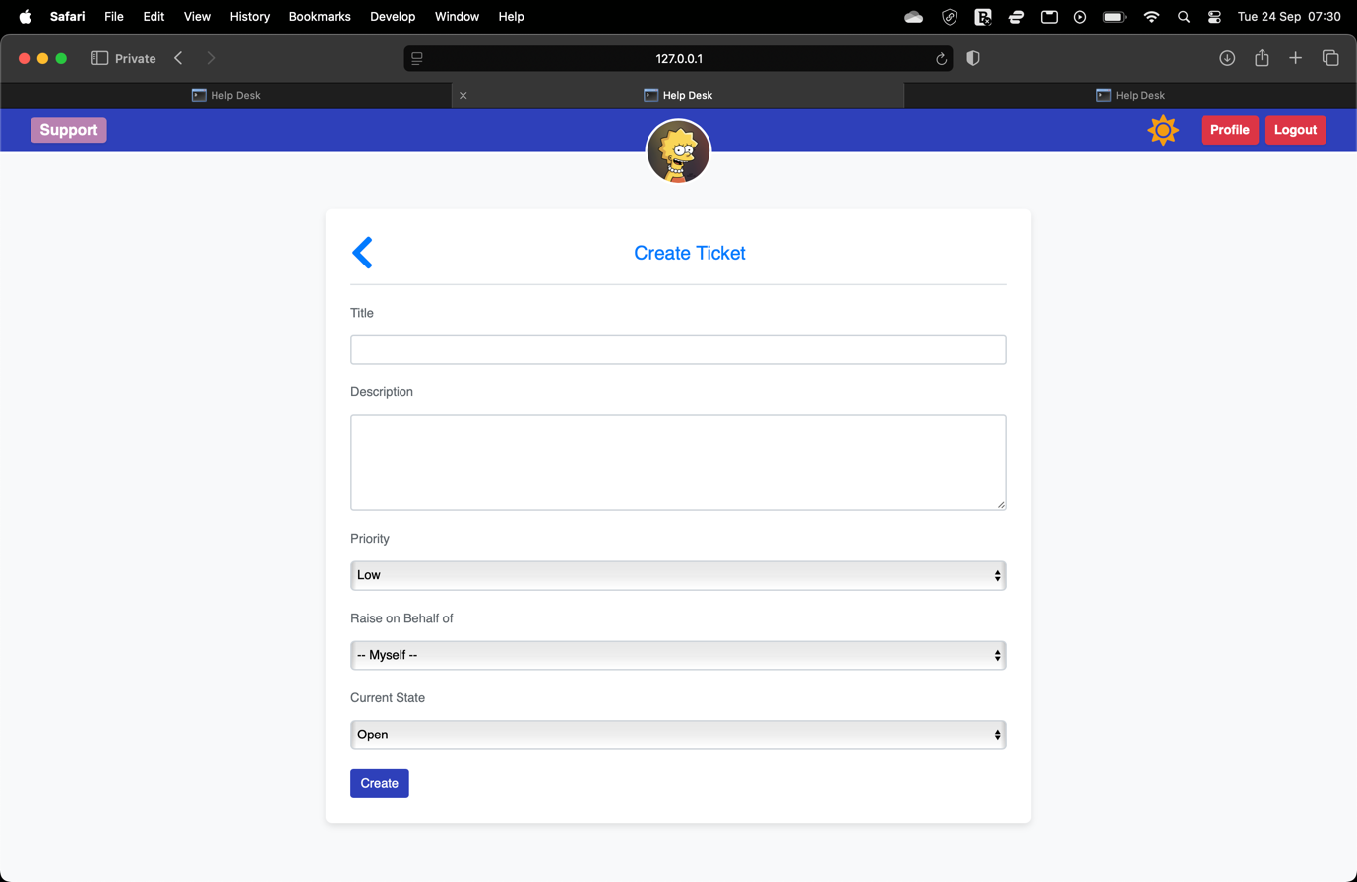
Ticket is automatically assigned as unassigned, allowing any support user to take it
Support users can create tickets and edit some ticket attributes:
- Title
- Description
- Priority
- Submitter (Raise on behalf of)
- State

Regular user create ticket page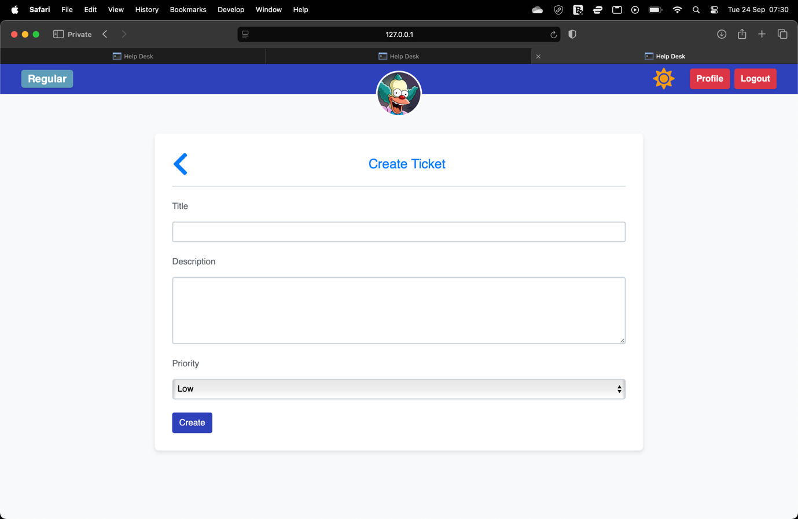
Status is automatically set to open
Assignee is automatically assigned as unassigned, allowing any support user to take it
Submitter is automatically set to user that creates it
Support users can create tickets and edit some ticket attributes:
- Title
- Description
- Priority

Any user create ticket duplicate ticket 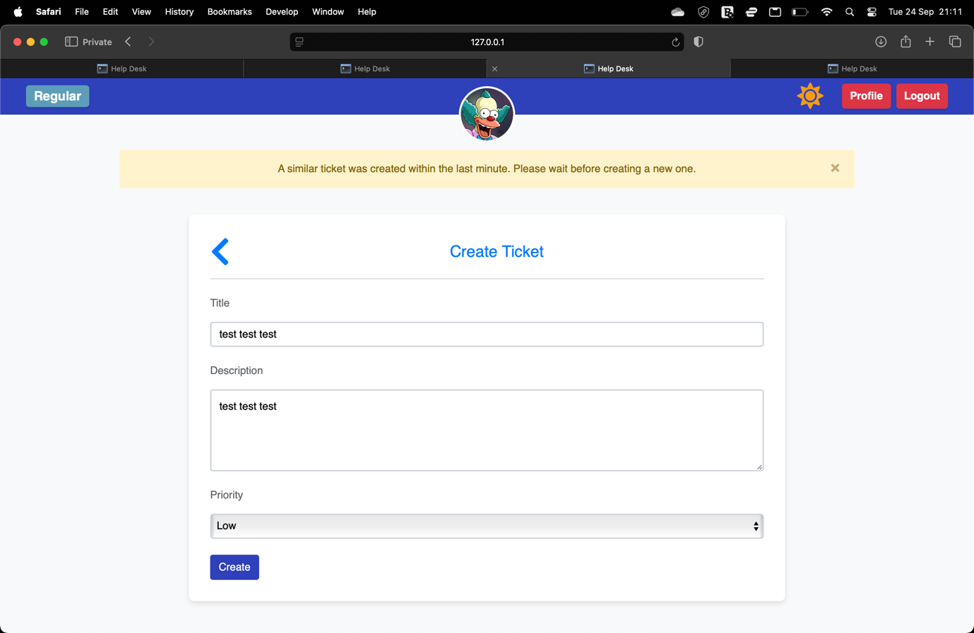
If any user creates another ticket with the same title within the same minute an error will show

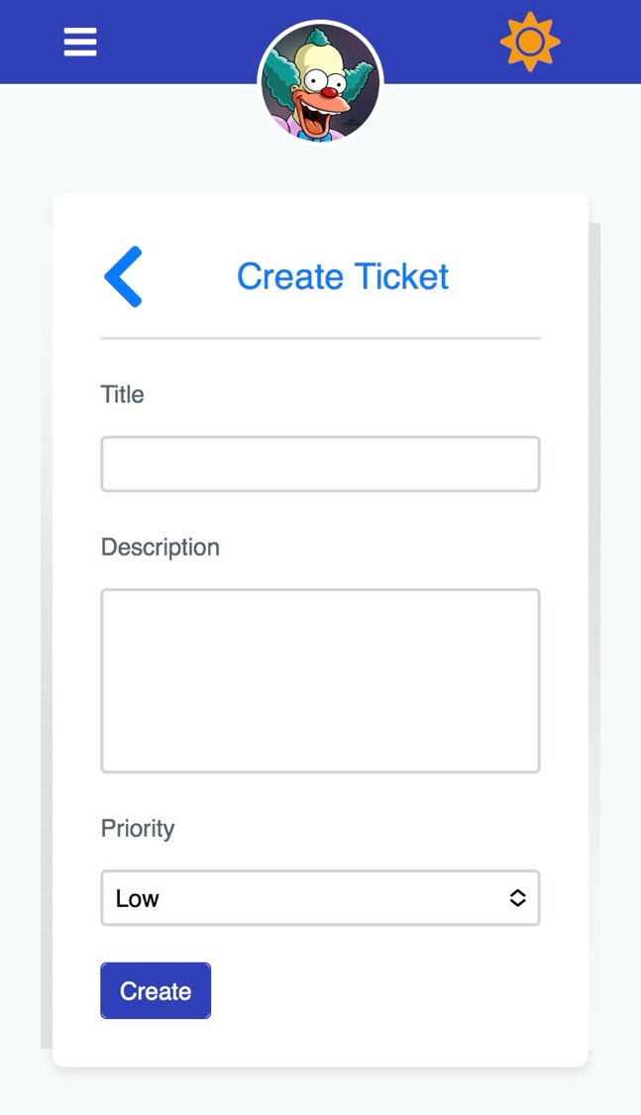
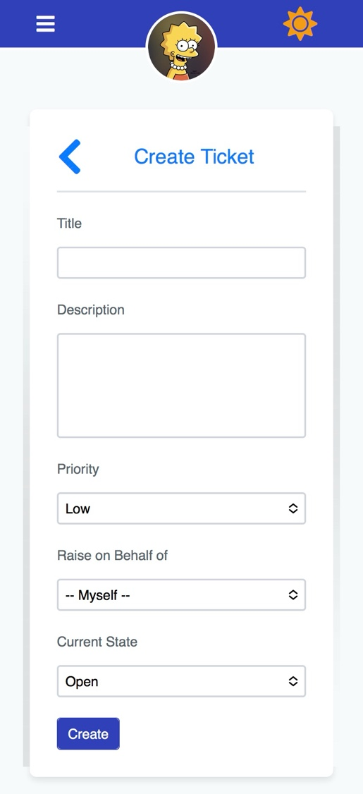
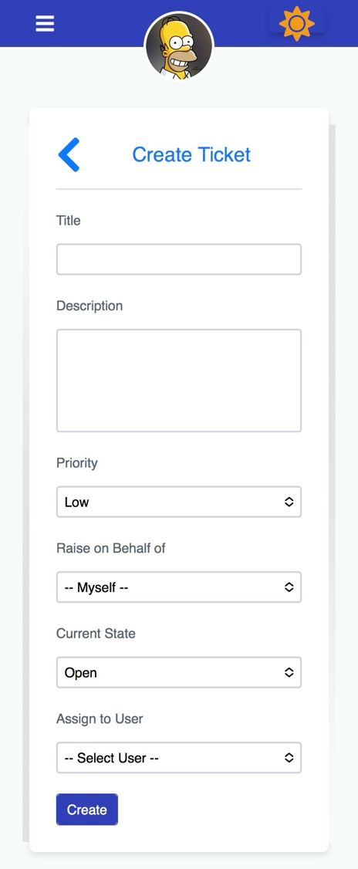
Create ticket page on mobile
Admin user create ticket page on mobile
Regular user create ticket page on mobile
Support user create ticket page on mobile

Admin user ticket detail page

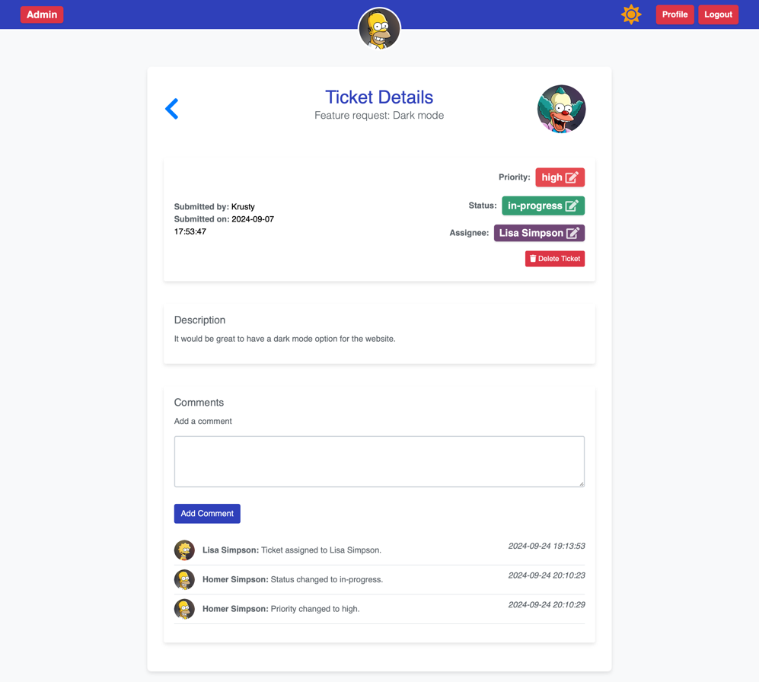
All ticket updates will be commented on the ticket, making it easy for all users to track the progress of the tickets
Admin can comment on tickets
Admin can delete ticket from this page
Admin can edit attributes of existing tickets:
- Priority
- Status
- assignee

Admin user ticket detail page

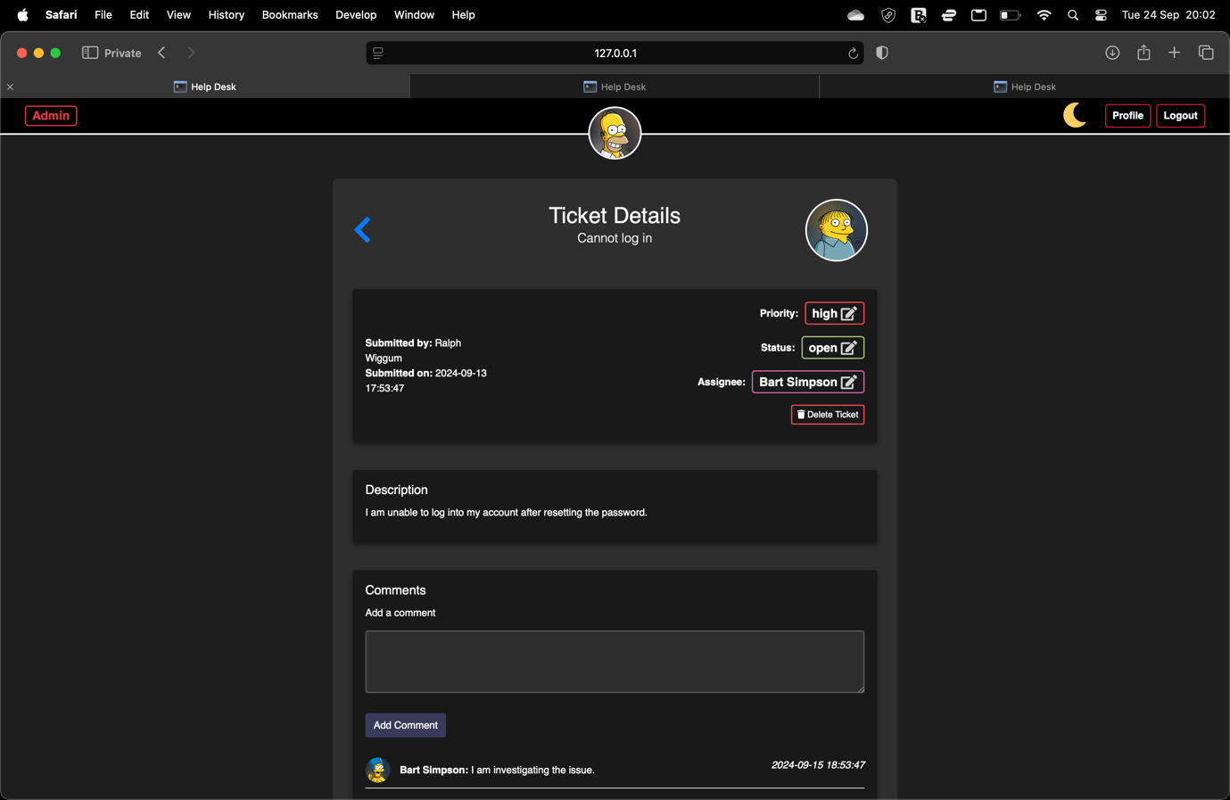
Dark mode for ticket detail page

Support user ticket detail page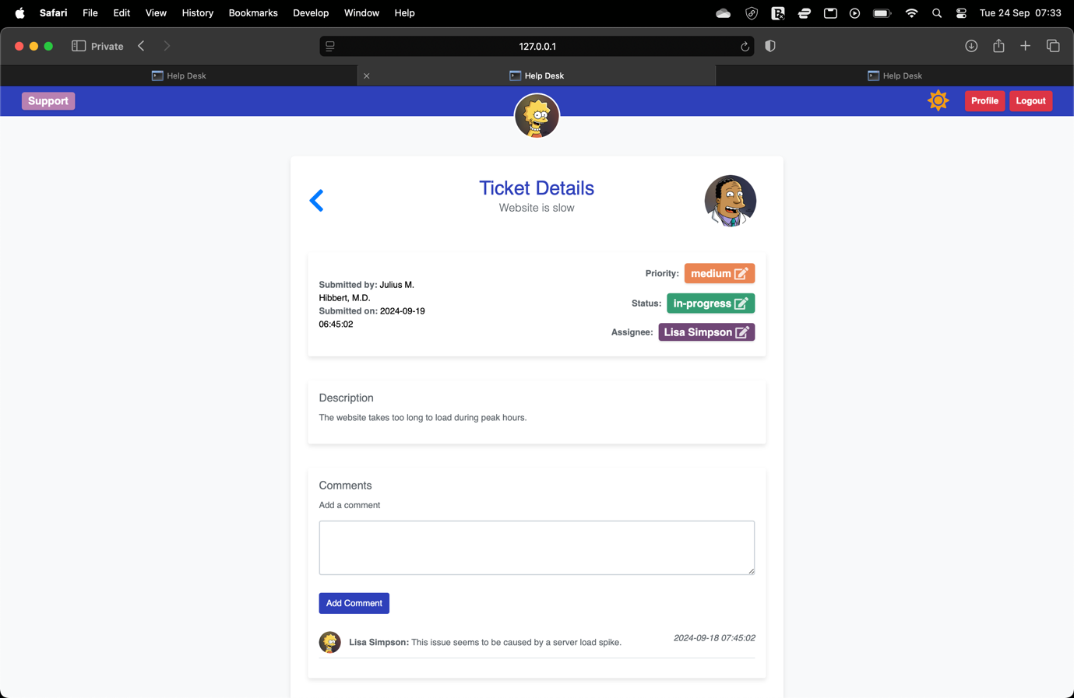
Support users can comment on tickets
Support can edit attributes of existing tickets:
- Priority
- Status
- assignee

Support user ticket detail page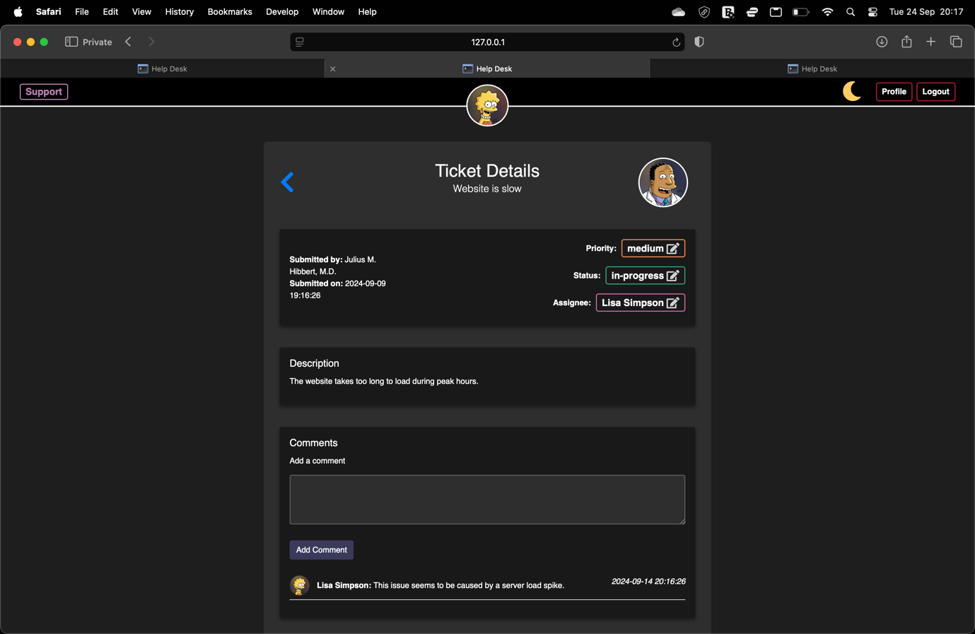
Dark mode for ticket detail page
Regular user ticket detail page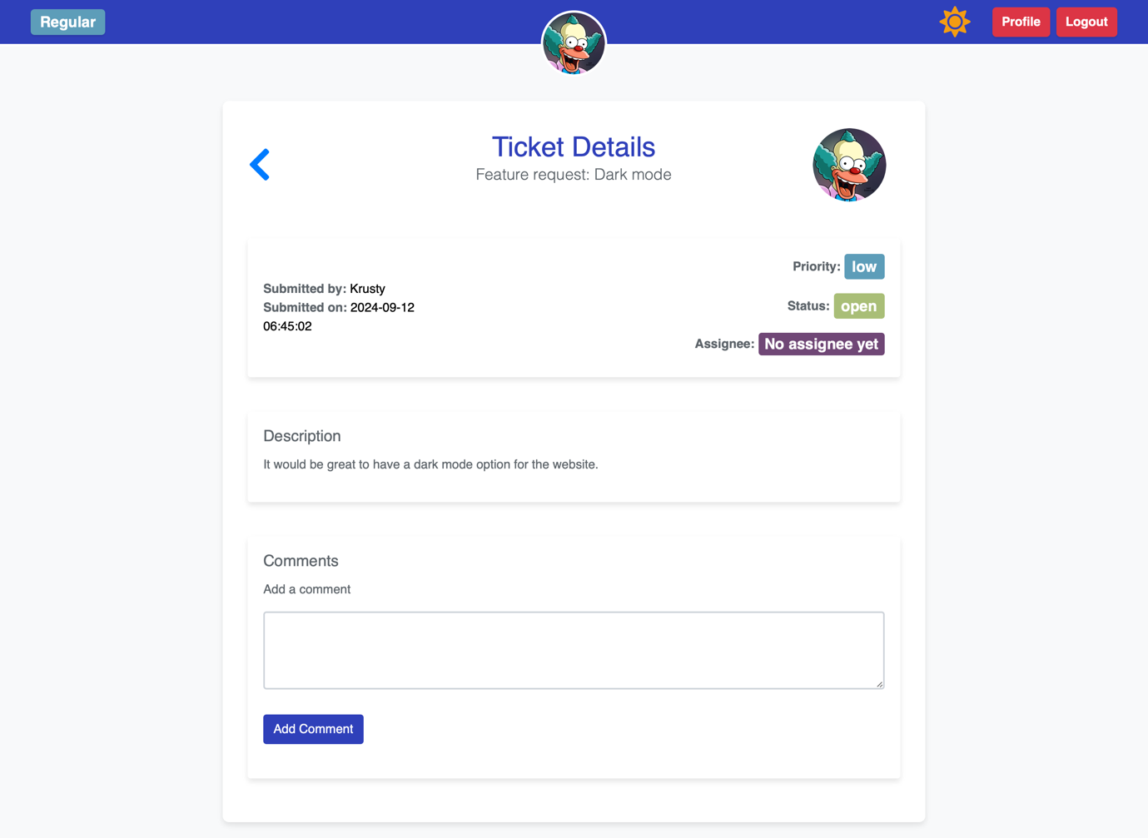
Regular users can comment on tickets
Regular users are not able to edit these attributes

Regular user ticket detail page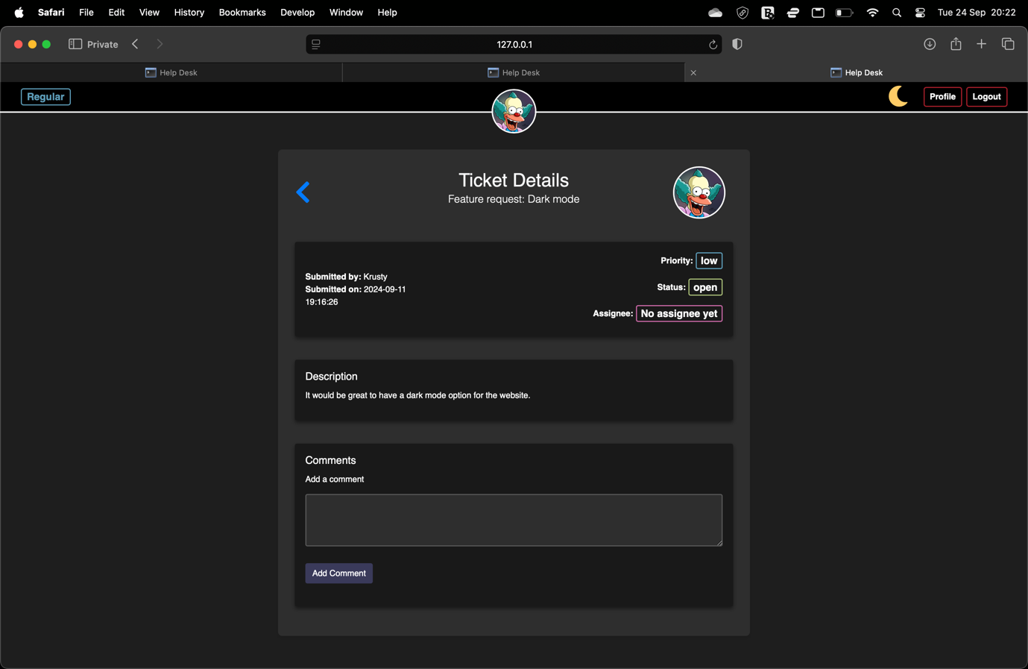
Dark mode for ticket detail page

Profile update page
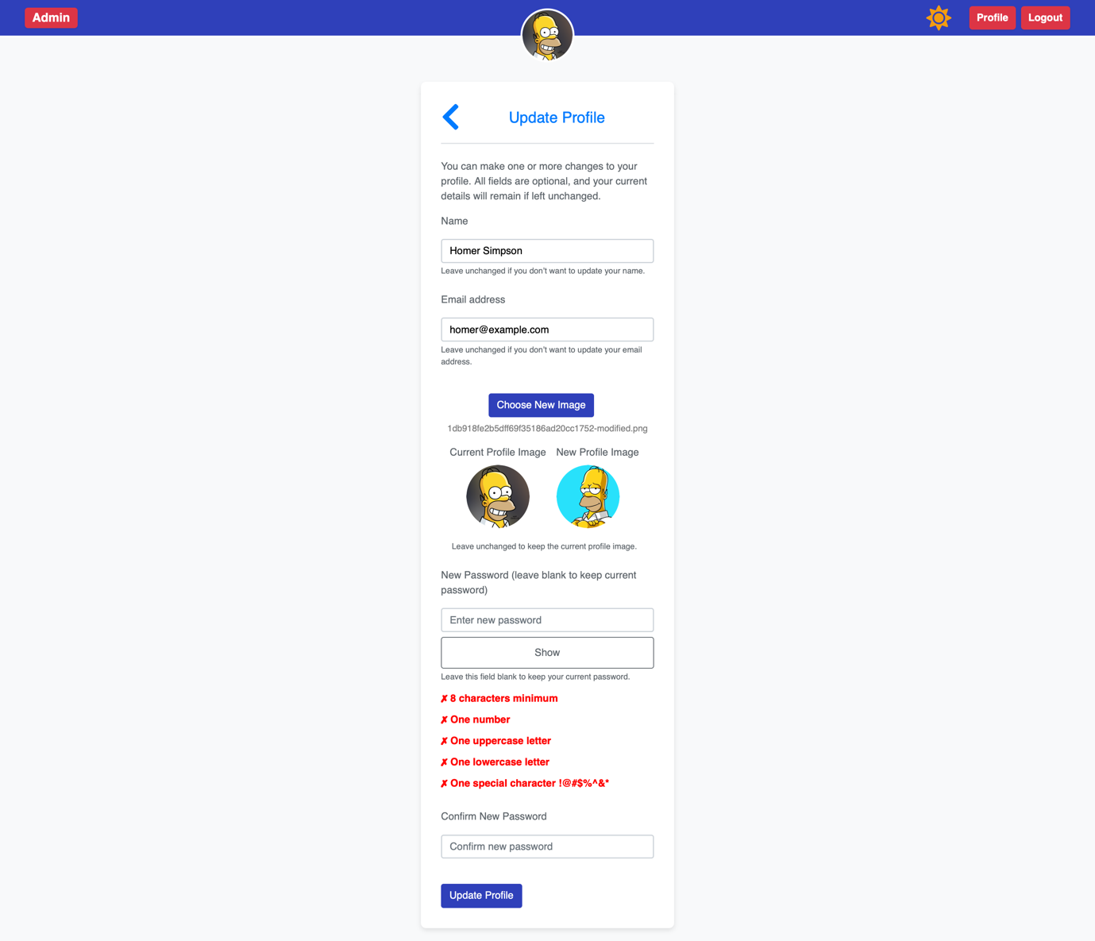
Same field validation as registration, to maintain consistency
Side by side profile image preview for user convenience
Same password validation as registration, to maintain consistency

Update profile page mobile view
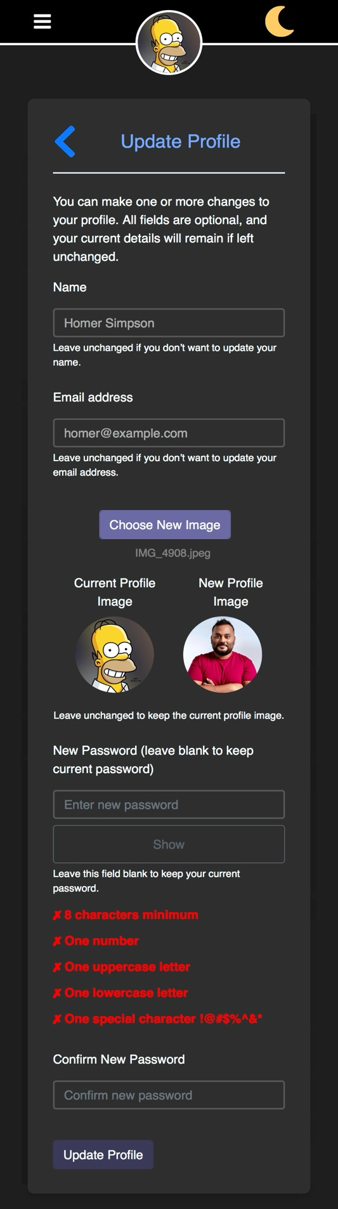
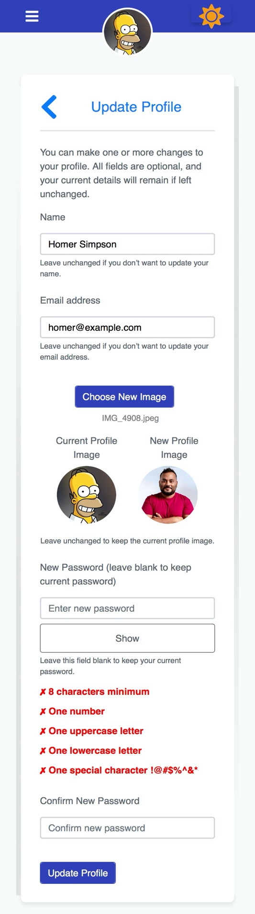
Consistent layout for mobile view for profile update page

User manual on key features
- Overview
The Help Desk Ticketing System is designed to efficiently manage IT support requests. It allows users to create and manage tickets, which can be assigned to support staff for resolution. The system features role-based access control and a user-friendly interface optimised for both desktop and mobile devices, including night mode for a comfortable viewing experience in low-light environments.
- Accessing the System
  - Login/Registration
    - Home Page:
    - On the homepage, you can either log in or register for an account.
    - Login: Enter your email and password to access your account.
    - Register: If you're new, register by providing your name, email, password, and selecting a user role (Admin, Support, or Regular User). Ability to register as Admin only allowed for marking purposes.
    - Sample credentials have been provided for marking purposes, in practice credentials would never be displayed like this.
  - User Roles:
    - Admin: Has full control over the system, including assigning tickets, deleting tickets, and managing users.
    - Support Staff: Manages tickets assigned to them, updates their status and priority, and comments on tickets. They can also assign tickets to any support staff.
    - Regular Users: Can create tickets, view and comment on all tickets, but their ticket pages only display tickets relevant to them. This setup reflects typical user behaviour, where users focus on their own tickets but occasionally need to comment on others, such as a manager providing input.

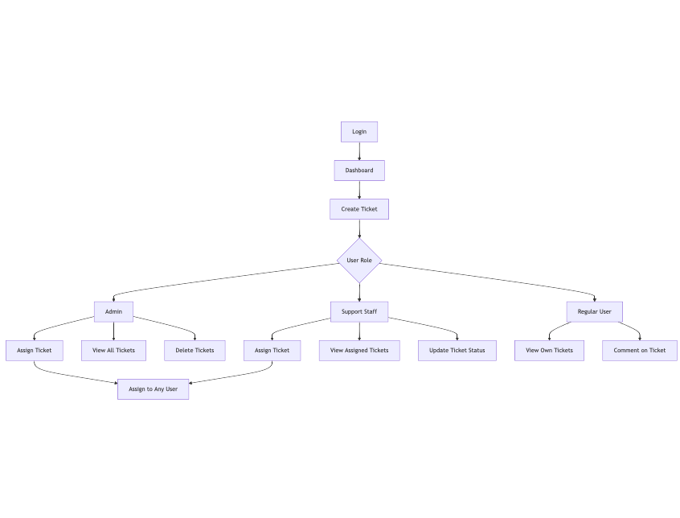
Figure 4 - User flow diagram

- Dashboard & Navigation
  - Navbar & Profile
    - Once logged in, a role-specific navbar is displayed:
      - Theme Toggle (Light/Dark Mode): Users can switch between light mode (default) and night mode by clicking the theme toggle button. Night mode is beneficial for users working in dark environments as it reduces eye strain and improves comfort.
      - Profile & Logout: Edit your profile and sign out.
  - Night Mode:
    - Full Night Mode Support: The system provides a fully implemented night mode for all pages. This mode reduces the amount of blue light emitted by the screen, which helps reduce eye strain, especially in dimly lit environments or during night-time use. The design also ensures that the contrast and visibility of text and elements are preserved, maintaining accessibility in all environments.
- Ticket Management
  - Creating a Ticket
    - Go to the Create Ticket page.
    - Fill out the form with the following details:
      - Title: A short description of the issue. (Any user)
      - Description: A detailed explanation of the problem. (Any user)
      - Priority: Select from low, medium, or high. (Any user)
      - Status: Set to “Open” by default (Only Admins and Support users can modify this).
      - Assigned to: Only Admins can assign the ticket to support staff during ticket creation.
      - Raise on behalf of: Set to user creating ticket by default (Only Admins and Support users can modify this).
    - Submit the form to create the ticket.
  - Viewing & Editing Tickets
    - A 'View' button was added specifically for marking purposes, to clearly demonstrate that the webapp includes a read-only page for tickets. In practice, however, support and regular users are more likely to use the 'Update' button, as interacting with a ticket typically requires making changes, rather than simply viewing it in a read-only format.
    - All ticket rows will have priority and status badges (with appropriate colouring of badges) to be able to quickly glance at the table and see what needs to be prioritised.
    - Admin users
      - Unassigned tickets page
        - For admins this page will show all tickets currently available to be assigned
        - Assign to user toggle
          - This feature allows for Admins to quickly see all unassigned tickets and their priorities/statuses so that they can manage the tickets as a whole. This feature is only given to admins as in my experience as IT support only the admin had ever needed a feature to quickly assign tickets to support users from the table view
        - Delete button
          - To be able to quickly delete a ticket that either isn’t needed anymore, another feature that from experience is suited to Admins that need to manage the tickets as a whole
      - Assigned tickets page
        - For admins this page will show all tickets that are currently assigned to users, helping admins gain a clear picture of overall assigned ticket progress.
      - All tickets page
        - For admins this page will show all tickets including closed tickets, again to provide an overall view where the support team is at with the tickets.
      - Closed tickets page
        - For admins this page will show all tickets with a closed status, from experience admins have needed to reopen a ticket if an issue wasn’t properly resolved.
    - Support users
      - Unassigned tickets page
        - For support users this page will show all available tickets to take.
        - “Take” button
          - This button allows support users to assign themselves to a ticket via one click, a feature that I found very useful as a support person.
      - Assigned tickets page
        - For support users this page will show tickets that are currently assigned to them, unlike Admin users they don’t need the overall picture of the ticket progress across the team, just their own workload.
      - Closed tickets page
        - For support users this page will show all of their own closed tickets, useful for when they need to reopen a ticket.
    - Regular users
      - Active tickets page
        - For regular users this page will show all tickets that the user has created.
      - Closed tickets page
        - For regular users this will show them closed tickets that they have submitted, this allows them to comment on the closed ticket to notify support if the ticket should not have been closed.
- Ticket Details
  - View Ticket Information
    - Click on a ticket to view its details, including:
    - Priority: The urgency of the ticket.
      - Different colours are given for different priorities
        - Low = blue
        - Medium = orange
        - High = red
    - Status: Whether the ticket is open, in-progress, or closed.
      - Different colours are given for different statuses
        - Open = lime green
        - In-progress = deep green
        - Closed = grey
    - Assignee: Who is responsible for handling the ticket.
    - Profile icon for ticket creator is showing on all ticket detail pages, making it very easy to tell the ticket creator for the support person that takes the ticket.
  - Editable Features:
    - Update Priority, Status, and Assignee: Admins and support users can click on badges to update these details using modals.
    - Comments: Any user can add comments to discuss the issue or provide updates on progress.
  - Delete Tickets (Admin Only):
    - Admins can delete tickets if they are no longer needed.
- Profile Management
  - Updating Profile Information
    - Users can update their name, email, and password via the Profile Update page.
    - If you don't wish to change your password, leave the password field blank.
    - Password requirements: minimum of 8 characters, one uppercase letter, one lowercase letter, one number, and one special character.
    - Users can upload new profile image; they will be shown current and new images side by side so that they can preview the new image before updating their profile with it
- Security Features
  - CSRF Protection: All forms are protected by CSRF tokens to prevent cross-site request forgery.
  - Password Security: Passwords are hashed using industry-standard methods to ensure account security.
- Additional Features
  - DataTables Integration:
    - Tables used to display tickets (e.g., in the assigned, unassigned, closed, and all tickets pages) are powered by DataTables, which allows for:
    - Pagination: Allows for easy navigation through large sets of tickets.
    - Editable row count: Allowing to change row count per page.
    - Sorting: Tickets can be sorted by title, priority, status, assignee, and more.
    - Search: Quickly find tickets by typing into the search bar.
    - Badge in the top left for admin and support that will change to more urgent colours as the number of active tickets increase. If the active ticket count is higher than 10 the badge is red, between 5 and 10 it is yellow, less than that the badge is green, this will help admin and support users to quickly tell the team-wide workload left, this would have been a useful feature to have on the ticketing platform when I was it support.
      - These numbers have been used as an example, from experience, these numbers would be set higher in overall
  - Flash Messages:
    - System notifications (e.g., ticket creation success) are displayed as flash messages after performing an action.
  - Responsive Mobile View:
    - The system is designed to be fully responsive, ensuring a seamless experience on mobile devices, tablets, and desktops.
    - Mobile Support:
    - Mobile-Friendly Navigation: A collapsible navigation bar and dropdowns ensure easy use on small screens.
    - Action Buttons: Elements such as the "Create Ticket" button become floating action buttons on mobile screens for easier access.
    - Optimised for Touch Inputs: Buttons and input fields are designed to be large enough for touch inputs, enhancing usability on mobile devices.
    - This is crucial for users who may need to access the system on the go, enabling them to manage tickets from any device.
    - All functionality and information available on the desktop version are available on the mobile version.
- System Requirements
  - Browser Support: The system is compatible with modern web browsers (Chrome, Firefox, Safari, Edge).
  - Mobile Optimisation: Fully responsive and mobile-friendly design ensures ease of use on smaller screens like smartphones and tablets.

Task 2

Web Application Development Using Agile Methodology

Introduction
The Help Desk Ticketing System was developed to streamline IT support management. The system was built using Flask, SQLite, and Bootstrap, and supports role-based ticket management for Admins, Support Staff, and Regular Users. While the project did not follow strict sprints, an agile-inspired approach was adopted, focusing on continuous feedback, unit testing, and version control. Feedback from both engineers and non-engineers was integrated into the development process, allowing for continuous improvement.

Agile Development Practices Used

Iterative Development with Continuous Feedback)
Throughout the development process, feedback was continuously gathered from both engineers and non-engineers. Engineers provided input on system performance and backend improvements, while non-engineers focused on the usability and design of the interface. Based on this feedback, several improvements were made, including enhancing mobile responsiveness and streamlining the ticket creation workflow. Some of these improvements include:
  - Better name validation
  - Profile image feature
  - Profile edit page
  - Listing password requirements on screen

Version Control with Git
Git was used for version control, ensuring that each feature and bug fix was tracked throughout the development process. Frequent commits were made to manage different iterations of the system, and the complete commit history is available on the project's GitHub repository. This approach provided a clear audit trail of the development process and allowed for the safe integration of new features.

The full repo and it’s committed history can be found here: https://github.com/Hiru5han/QA-project-weabapp

Unit Testing and Quality Assurance
Unit testing was implemented using pytest to verify critical system functionalities such as user authentication, ticket creation, and role-based access control. Although full test coverage wasn’t achieved, the tests ensured that core features worked reliably and that any bugs were identified early in the development process. Presently coverage is 84% as can be seen in Figure 4 below

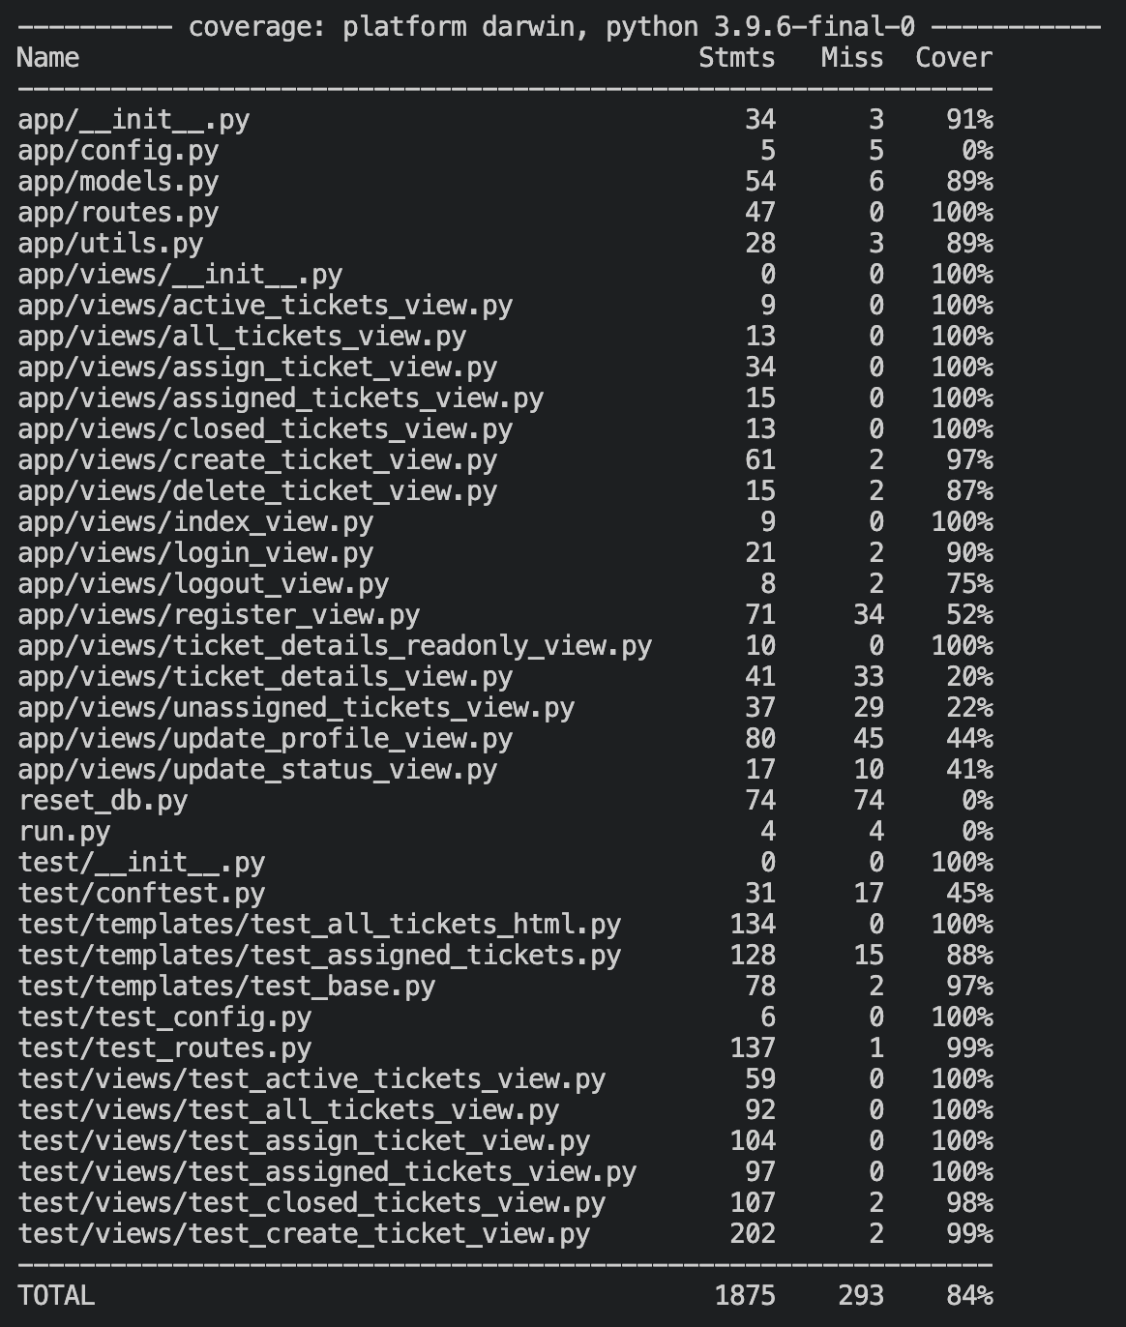
Figure 5 - Unit test coverage
By adopting agile principles such as continuous feedback, version control with Git, and unit testing, the Help Desk Ticketing System was iteratively improved. However, following a more structured approach with defined sprints could have further streamlined the process, allowing for better time management, clearer milestones, and more predictable outcomes. Regular sprint reviews would have helped to formalise feedback integration and ensure that tasks were completed in manageable increments.

Task 3

Report II: Agile Overview

Introduction
Agile methodologies have revolutionised software development by promoting adaptability, collaboration, and iterative progress. Among the various Agile frameworks, Scrum has become one of the most popular, offering a structured approach for managing complex projects. This report looks and analyses the Scrum framework, comparing it to other Agile methodologies such as Kanban and Lean, and proposes a hybrid approach to address some of its limitations, enhancing its flexibility for dynamic environments.

Scrum Framework Overview
Scrum was developed by Ken Schwaber and Jeff Sutherland in the early 1990s, it is an iterative framework designed for managing complex software development projects (ScrumGuides, 2020). Scrum revolves around fixed-length durations of work called sprints, usually taking between 2-4 weeks. Each sprint begins with a sprint planning session, where the Product Owner prioritises items from the Product Backlog, and the Development Team commits to delivering a set of tasks during the sprint (Schwaber & Sutherland, 2020).

The core roles within Scrum are clearly defined:
- Product Owner: Responsible for maximising product value by prioritising the backlog.
- Scrum Master: Facilitates Scrum practices and removes impediments.
- Development Team: A self-organising, cross-functional group of professionals delivering increments of product (Scrum.org, 2020).

By maintaining a steady schedule through daily stand-ups, sprint reviews and retrospectives, Scrum ensures a continuous improvement process and adaptability throughout the development lifecycle (Schwaber & Sutherland, 2020).

Comparison with Kanban
Unlike Scrum, Kanban follows a continuous delivery model without fixed-length iterations (Artem Golubev, 2023). It was developed by Toyota in the 1940s, Kanban is visualised through a Kanban Board, where tasks move through columns representing different stages of work (DZone, 2023). The system focuses on limiting Work-In-Progress (WIP), allowing for efficiency and flexibility as tasks can be reprioritised in real time.

Kanban is particularly suitable for teams having to deal with unplanned or urgent work, where fixed sprints may introduce delays. However, Scrum offers greater predictability through its sprint structure, which can help teams focus and commit to clear goals within a defined period (Steady, 2024). While Kanban’s flexibility provides advantages for dynamic environments, Scrum’s structure ensures consistent delivery of product increments, making it better suited for projects requiring regular feedback cycles and stakeholder engagement.

Comparison with Lean
Lean software development, which focuses on reducing waste and maximising customer value, shares many principles with Kanban but emphasises even more efficiency (Krush, A, 2024). The key principles of Lean include delivering as fast as possible, empowering the team, and amplifying learning through continuous improvement (Artem Golubev, 2023).

While Lean promotes eliminating non-value-adding activities, Scrum focuses more on managing complex projects through structured roles and iterative feedback (417 Project Management, 2023). Lean’s flexibility and focus on eliminating waste make it especially effective for startups or smaller teams working on MVPs (minimum viable products), while Scrum’s prescriptive nature offers better discipline for larger projects with well-defined requirements.

Critical Evaluation of Scrum
Scrum’s iterative approach and defined roles provide a clear structure that fosters collaboration and adaptability. The regular use of retrospectives ensures teams can continuously learn and improve, aligning with Agile’s focus on adaptability (Schwaber & Sutherland, 2020). However, Scrum’s dependence on time-boxed sprints can be a limitation in rapidly changing environments. For instance, when priorities shift mid-sprint, teams must often wait until the next planning session to adapt, potentially slowing down the overall workflow (DZone, 2023).

Moreover, the various Scrum ceremonies (planning, stand-ups, reviews) can introduce overhead, especially for smaller teams or projects where daily communication is less critical (Steady, 2024). Although these ceremonies promote transparency and accountability, they may not always justify the time invested in them.

Proposed Improvement: Hybrid Scrum-Kanban (Scrumban)
To address Scrum’s rigidity and improve flexibility, a hybrid approach combining elements of Kanban into Scrum, which is often referred to as Scrumban could address these challenges. By introducing Kanban Boards to visualise and manage Work-In-Progress (WIP) limits, Scrum teams could dynamically handle unplanned tasks without disrupting the sprint structure (Artem Golubev, 2023).

This approach would retain Scrum’s strength in regular feedback and structured sprints, while leveraging Kanban’s ability to handle fluctuating priorities in real-time. Teams could incorporate WIP limits during sprints and review task flow continuously, ensuring they remain adaptable without compromising on delivery cadence. Tools like Jira or Trello can be used to facilitate this hybrid model, providing real-time visibility into task progress and allowing more flexibility in task allocation (Krush, A, 2024).

Conclusion
In conclusion, Scrum’s well-defined roles, structured sprints, and iterative feedback cycles make it a great framework for managing complex software development projects. However, integrating elements of Kanban, such as WIP limits and continuous task prioritisation, can address its rigidity, improving adaptability in dynamic environments. This hybrid approach would allow organisations to maintain the benefits of Scrum’s structured framework while adapting to changing demands more efficiently.

Bibliography
- 417 Project Management (2023). 417 Project Management. [online] 417 Project Management. Available at: https://www.417pm.com/blog-2-1/scrums-historical-path [Accessed 25 Sep. 2024].
- Artem Golubev (2023). Scrum vs. Kanban vs. Lean: Choosing Your Path in Agile Development - testRigor AI-Based Automated Testing Tool. [online] testRigor AI-Based Automated Testing Tool. Available at: https://testrigor.com/blog/scrum-vs-kanban-vs-lean-choosing-your-path-in-agile-development/ [Accessed 25 Sep. 2024].
- DZone (2017). Agile Framework Comparison: Scrum vs Kanban vs Lean vs XP - DZone Agile. [online] dzone.com. Available at: https://dzone.com/articles/agile-framework-comparison-scrum-vs-kanban-vs-lean [Accessed 25 Sep. 2024].
- Krush, A. (2017). Agile Framework Comparison: Scrum vs Kanban vs Lean vs XP › ObjectStyle.com. [online] www.objectstyle.com. Available at: https://www.objectstyle.com/blog/agile-scrum-kanban-lean-xp-comparison [Accessed 25 Sep. 2024].
- Schwaber, K. and Sutherland, J. (2020). The Scrum Guide the Definitive Guide to Scrum: The Rules of the Game. [online] Available at: https://scrumguides.org/docs/scrumguide/v2020/2020-Scrum-Guide-US.pdf [Accessed 25 Sep. 2024].
- Scrum.org (2020). Home | Scrum Guides. [online] scrumguides.org. Available at: https://scrumguides.org/.
- Steady (2024). Comparing Scrum, Kanban, and Lean Methodologies. [online] Steady. Available at: https://steady.space/blog/comparing-scrum-kanban-lean/ [Accessed 25 Sep. 2024].

